

计算机系统结构课程实验

总结报告

实验题目：动态流水线设计与性能定量分析

学号：1953072

姓名：肖鹏飞

指导教师：陆有军

日期：2021.12.11

1. **实验环境部署与硬件配置说明**

1.实验环境

实验软件：vivado 2016.2

仿真测试软件：ModelSim PE 10.4c

2.硬件配置

开发板：XILINX Artix-7 NEXYS 4 DDR

1. **实验的总体结构**

1.动态流水线的总体结构

CPU总体结构（按流水段分解）：

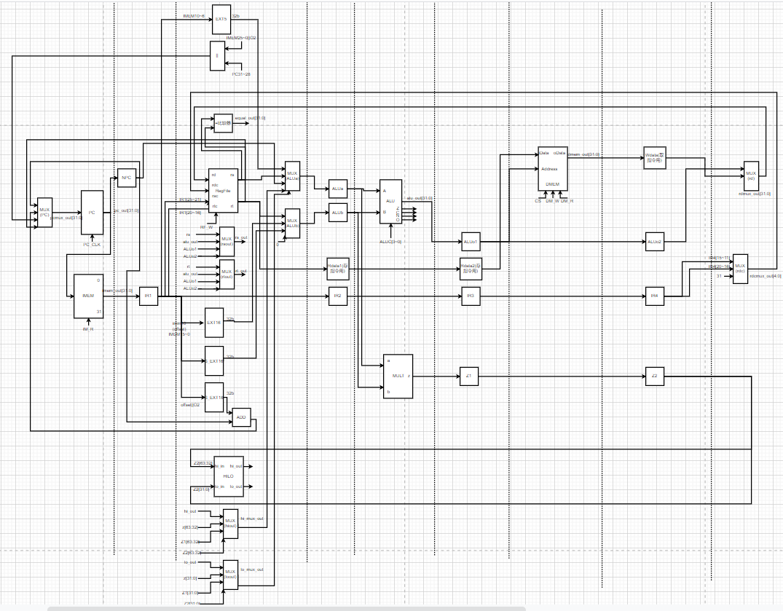

部件接口连接图：

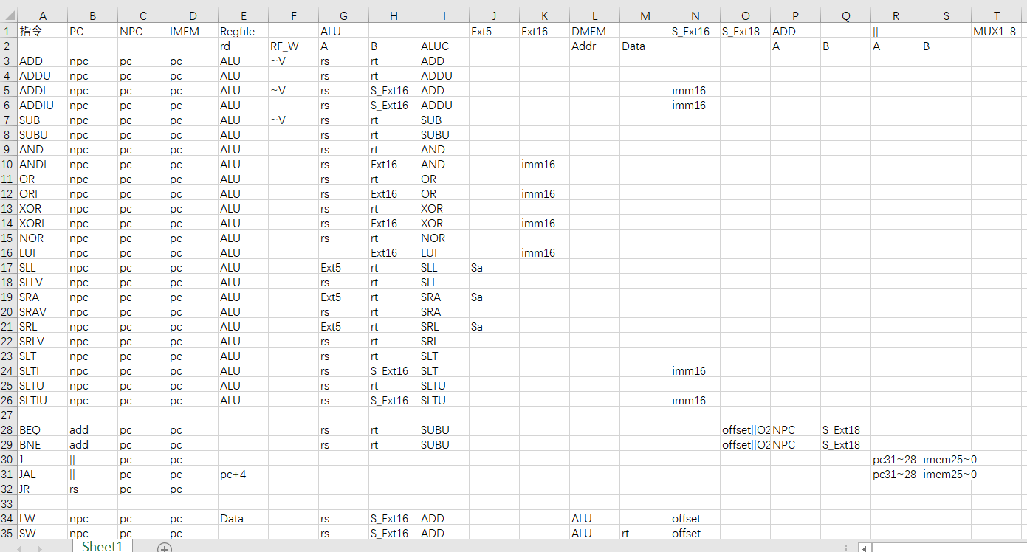

控制信号：

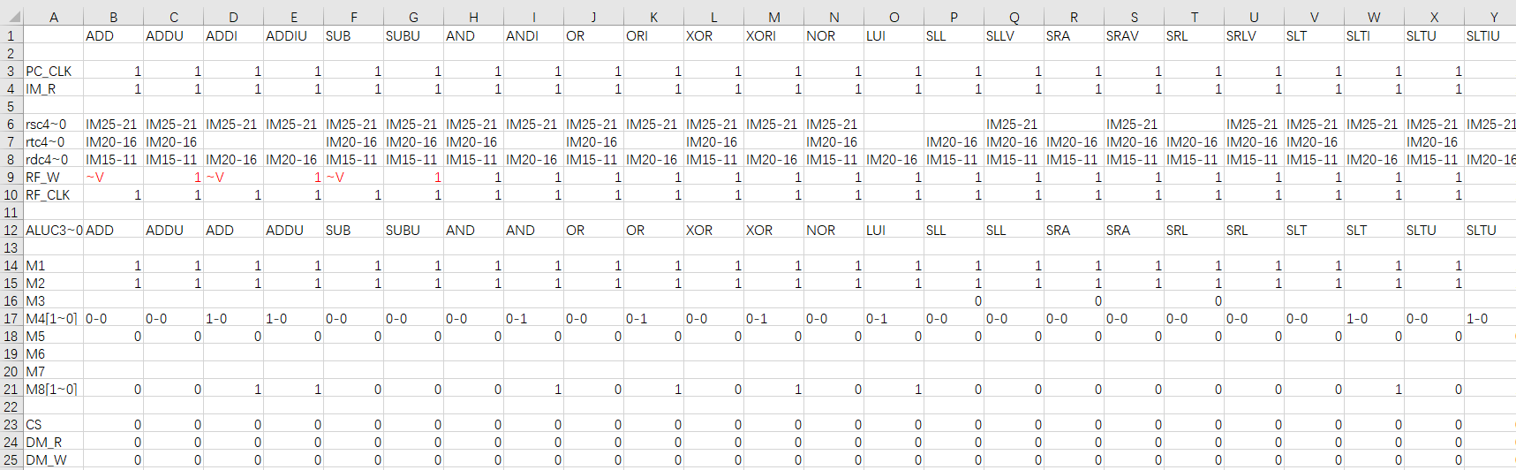

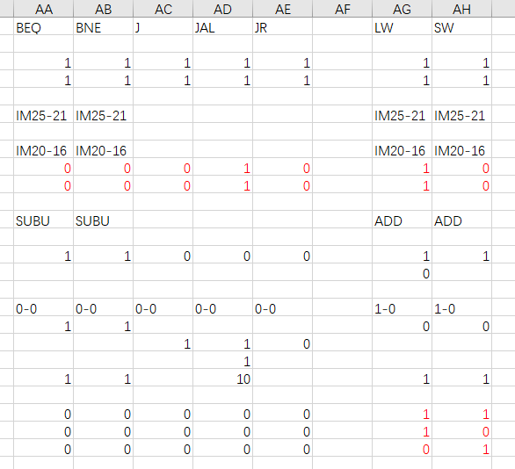

1. **总体架构部件的解释说明**

1.动态流水线总体结构部件的解释说明

(1).IF级部件

输入：PC来源，clk、reset等控制信号。

输出：和当前PC对应的指令及下一条PC。

作用：根据PC选择指令。

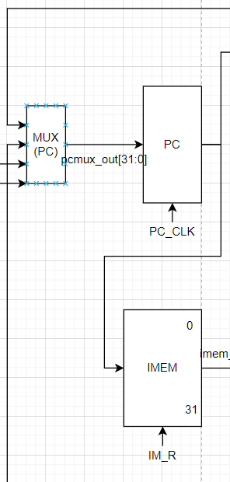

(2).IF-ID级段间流水部件

作用：流水存储取出的指令及PC+4。

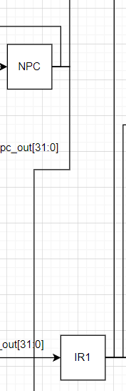

(3).ID级部件

输入：上一个流水段的指令，需要输入的寄存器地址和值，及各个部件需要的控制信号。

输出： 扩展后的数据，读出的rs和rt内容。

作用：数据扩展，转移指令的比较和计算，寄存器堆的读写，HI、LO寄存器的读写。

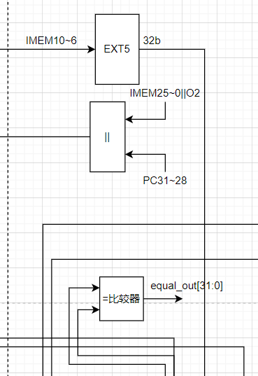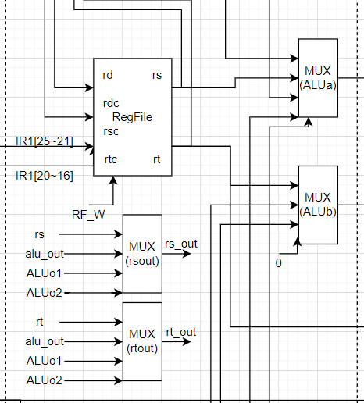

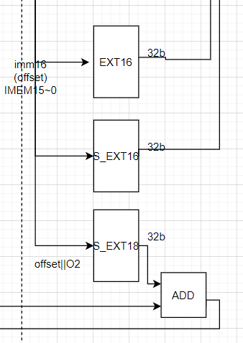

(4).ID-EX级段间流水部件

作用：流水存储rs、rt等寄存器的值及之后流水段的所需指令。

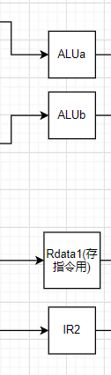

(5).EX级部件

输入：ALU的两个输入及需要的控制信号。

输出：ALU计算得到的结果。

作用：完成计算功能。

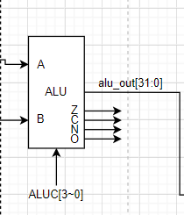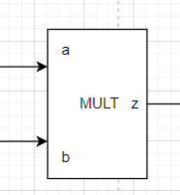

(6).EX-ME级段间流水部件

作用：流水存储ALU的计算结果及之后流水段的所需指令。

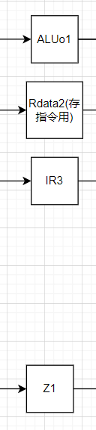

(7).ME级部件

输入：数据存储器的地址和数据及需要的控制信号。

输出：从数据存储器中取出的值。

作用：访问存储器，完成存取功能。

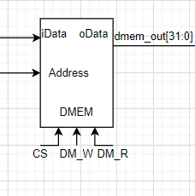

(8).ME-WB级段间流水部件

作用：流水存储DMEM的取出内容及之后流水段的所需指令。

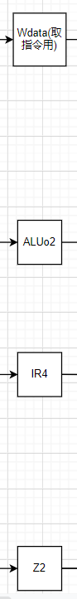

(9).WB级部件

输入：从DMEM取出的数据和ALU计算出的数据及需要的控制信号。

输出：寄存器堆的输入地址和数据。

作用：将数据写回寄存器堆。

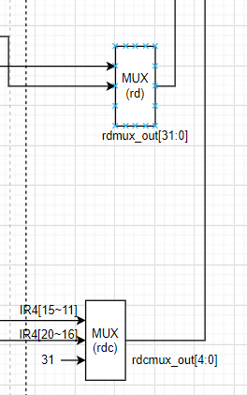

1. **实验仿真过程**

1.动态流水线的仿真过程

(1).前仿真过程

ModelSim波形图：

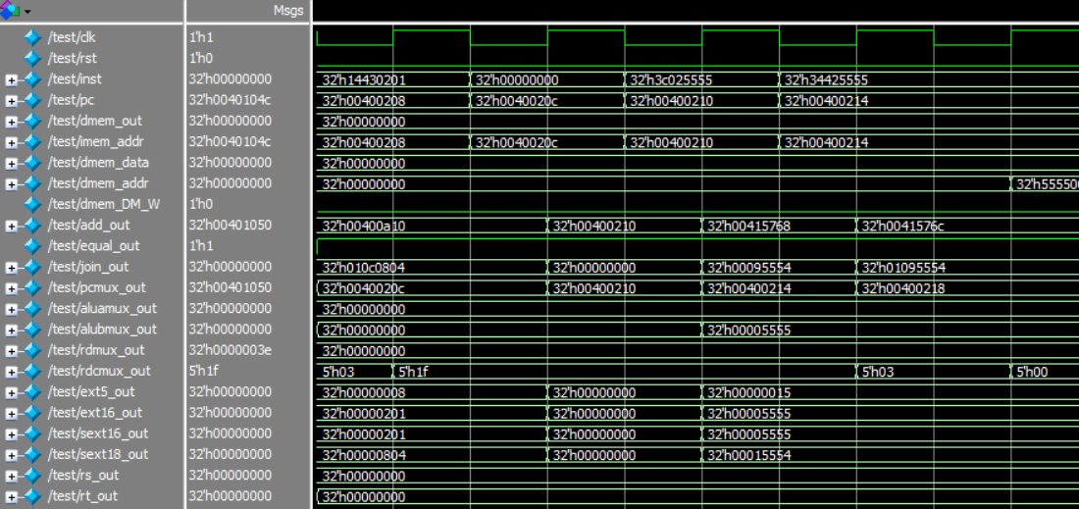

从Mars中获取coe文件和result文件：

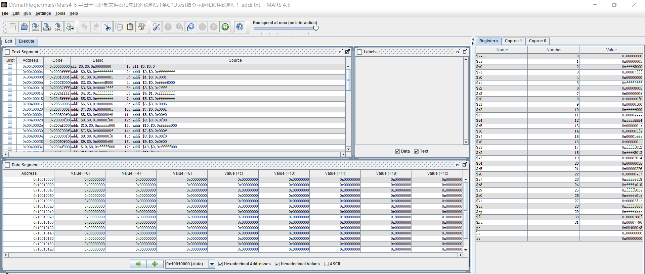

Mars导出的coe文件：

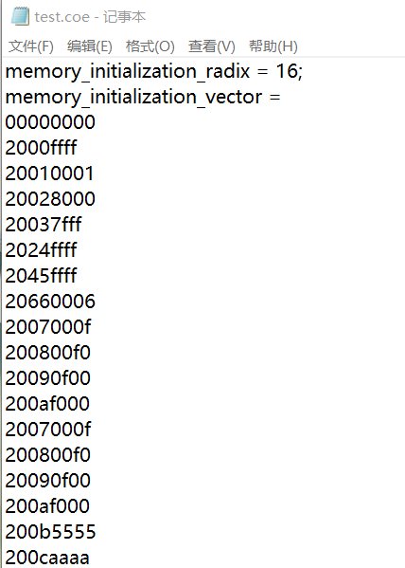

过程中打印的result.txt文件：

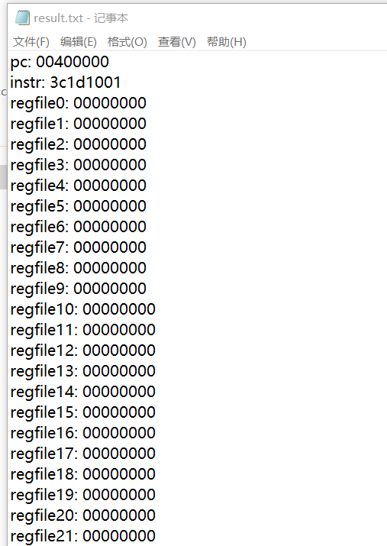

生成的result文件与Mars的执行结果在文本比较器中比较：

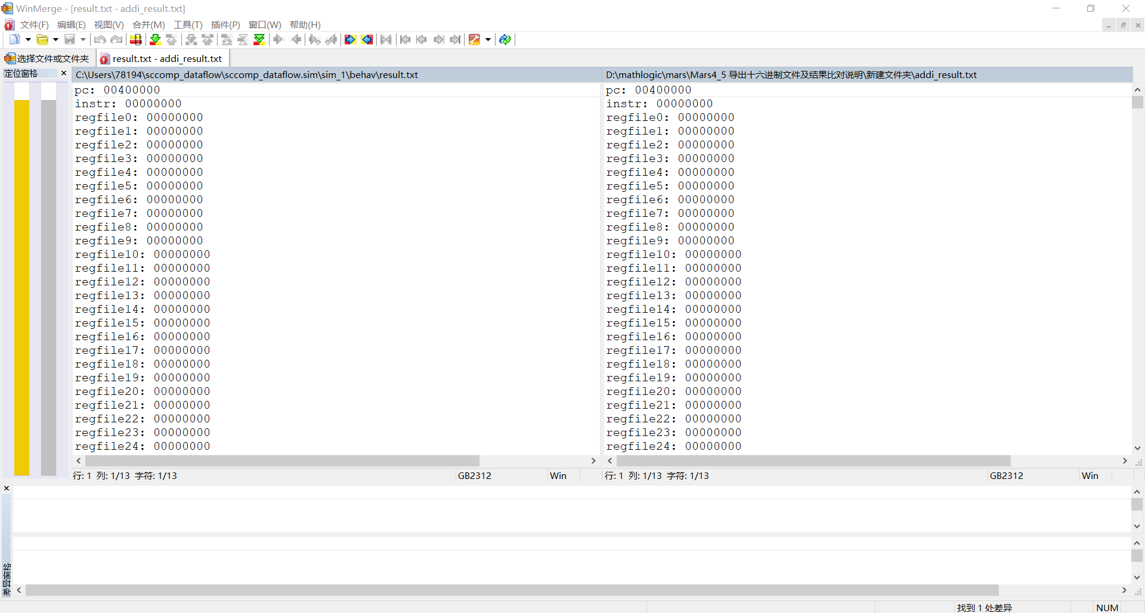

(2).后仿真

后仿真无法在testbench中打印寄存器的值与result比较，因此只能观察波形图。

图中的clk1为200倍分频之后的时钟。

起始时刻，存在数据通路延迟：

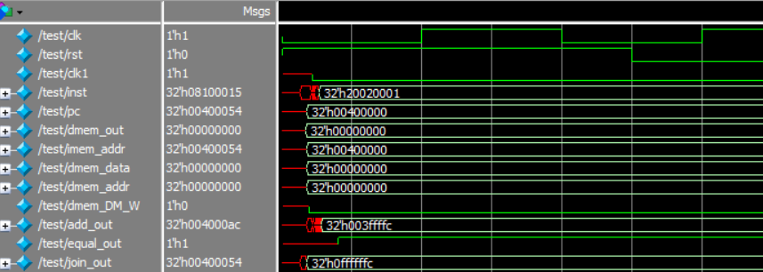

程序执行完成，各项数据稳定：

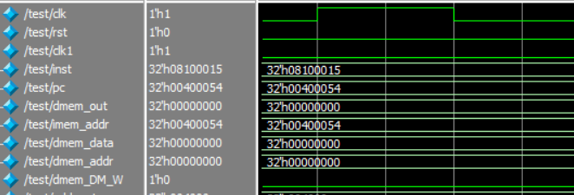

1. **实验仿真的波形图及某时刻寄存器值的物理意义**

1.动态流水线的波形图及某时刻寄存器值的物理意义

全局输出的信号量清单：



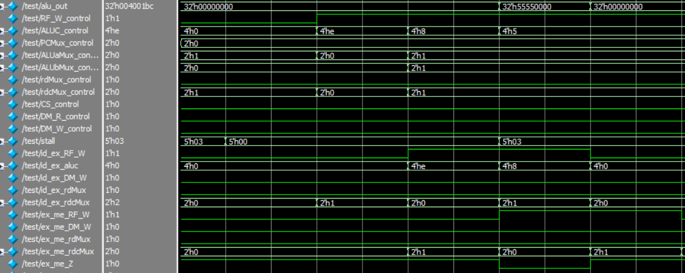

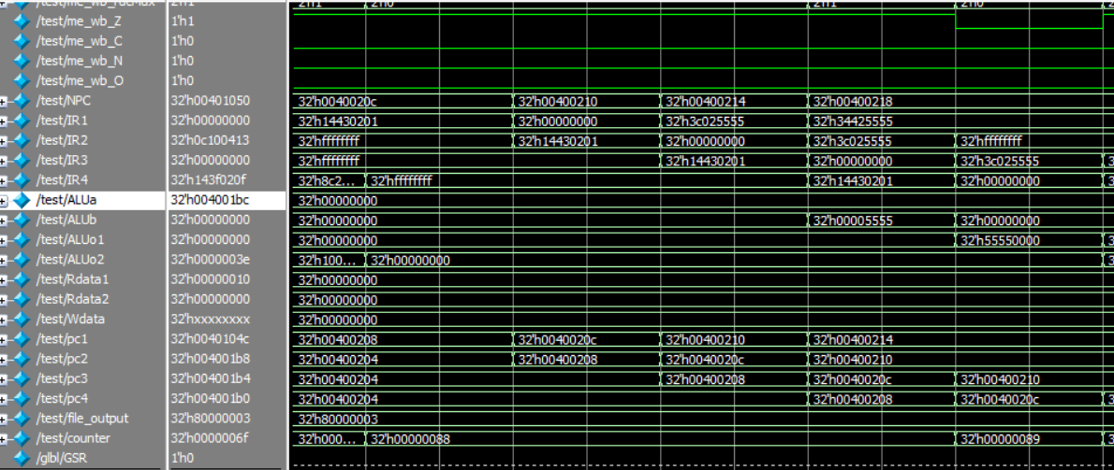

1.正常执行

横向看，分别是每一级的信号输出，纵向看，是每个时钟周期内每一级的当前输出。在下图中，指令在流水线中顺次流动，按照IF-IF-EX-ME-WB的顺序流动，并将每一级的输出和信号量传递到下一级。

PC与指令同步情况：

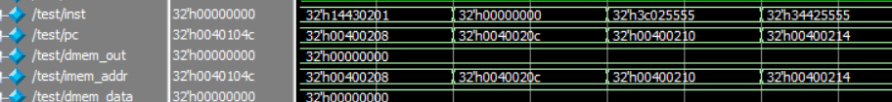

指令流水线情况：

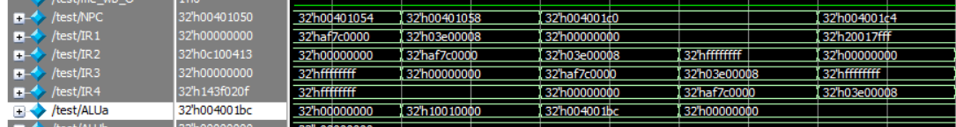

2.遇到数据冲突的暂停情况

横向看，分别是每一级的信号输出，纵向看，是每个时钟周期内每一级的当前输出。

解决数据冲突的方式根据前后的指令不同选择不同的方式。对于ALU相关的计算指令（ADDI等），使用数据前推来消除冲突。采用专用路径的方式将ex、me、wb段中未写入的内容送入id段作为读取内容。而对于内存操作（LW）、数据转移（JAL）等指令，则采用插入空指令的方式进行数据的推迟。

（1）.数据前推方法，专用路径，流水线不暂停

汇编指令，数据冲突：

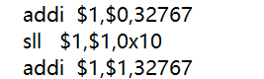

PC与指令同步情况：

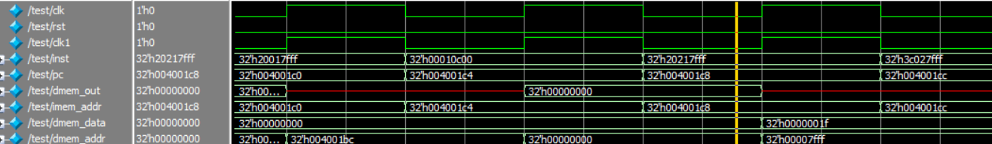

实际：流水线未暂停，正常流动：

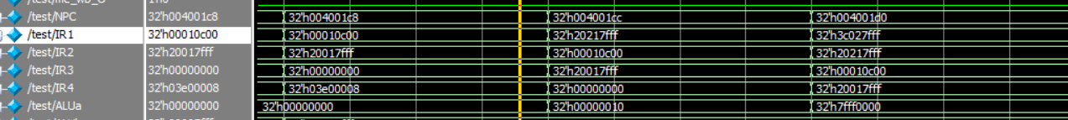

（2）.插入stall延迟情况

在下图中，指令发生数据冲突，流水线前半部分停止流动，在两者之间不断插入空指令，直到不再发生数据相关时继续流动。

PC与指令同步情况：

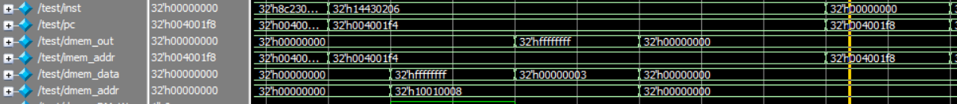

指令流水线情况：

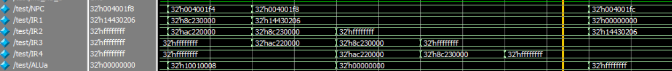

1. **实验验算数学模型及算法程序**

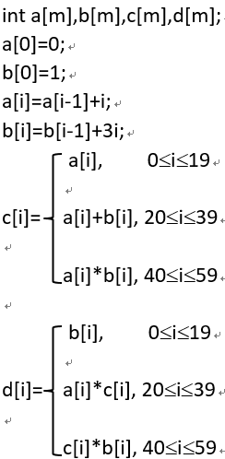

算法流程图：

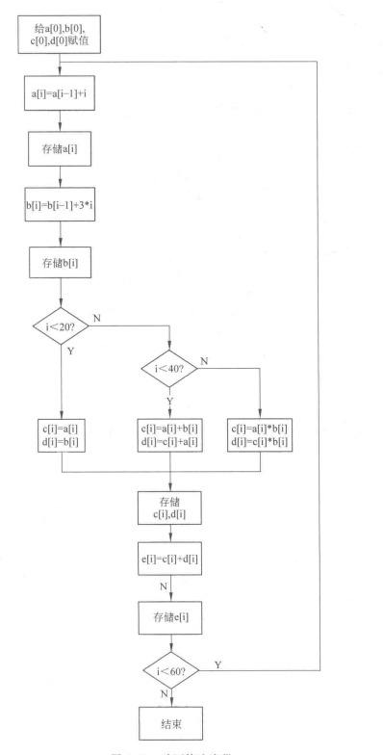

算法汇编代码：

.data

A:.space 240

B:.space 240

C:.space 240

D:.space 240

E:.space 240

.text

j main

exc:

nop

j exc

main:

addi $2,$0,0

addi $3,$0,1

addi $4,$0,0

addi $13,$0,0

addi $5,$0,4

addi $6,$0,0

addi $7,$0,1

addi $10,$0,0

addi $11,$0,240

addi $14,$0,3

addi $30,$0,0

lui $27,0x0000

addu $27,$27,$0

sw $2,A($27)

lui $27,0x0000

addu $27,$27,$0

sw $3,B($27)

lui $27,0x0000

addu $27,$27,$0

sw $2,C($27)

lui $27,0x0000

addu $27,$27,$0

sw $3,D($27)

loop:

srl $12,$5,2

add $6,$6,$12

lui $27,0x0000

addu $27,$27,$5

sw $6,A($27)

mult $14,$12

mflo $15

add $7,$7,$15

lui $27,0x0000

addu $27,$27,$5

sw $7,B($27)

slti $10,$5,80

bne $10,1,c1

lui $27,0x0000

addu $27,$27,$5

sw $7,D($27)

addi $15,$6,0

addi $16,$7,0

j endc

c1:

slti $10,$5,160

addi $27,$0,1

bne $10,$27,c2

add $15,$6,$7

lui $27,0x0000

addu $27,$27,$5

sw $15,C($27)

mult $15,$6

mflo $16

lui $27,0x0000

addu $27,$27,$5

sw $16,D($27)

j endc

c2:

mult $6,$7

mflo $15

lui $27,0x0000

addu $27,$27,$5

sw $15,C($27)

mult $15,$7

mflo $16

lui $27,0x0000

addu $27,$27,$5

sw $16,D($27)

endc:

add $28,$15,$16

lui $27,0x0000

addu $27,$27,$5

sw $28,E($27)

addi $5,$5,4

bne $5,$11,loop

在MARS软件中得到的预期结果：0x9fd0b7ea

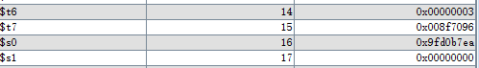

仿真得到的结果（前仿真，后仿真结果相同）：0x9fd0b7ea

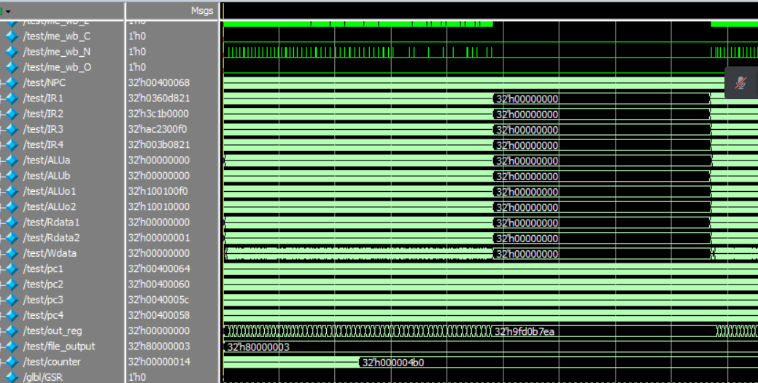

由以上两图可见仿真得到的结果符合预期，动态流水线在仿真阶段正确运行。

1. **实验验算程序下板测试过程与实现**

CPU测试pc值：

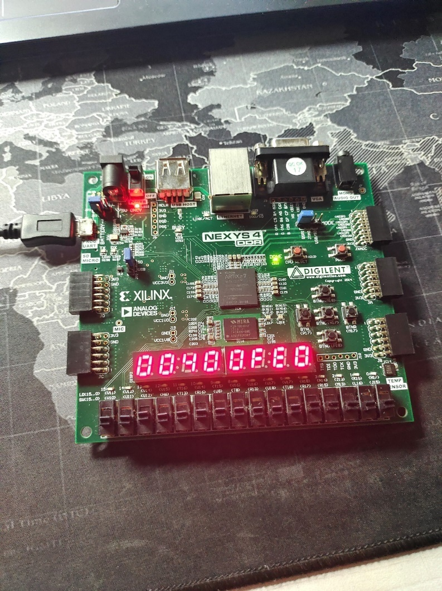

下板过程中的数组内容：

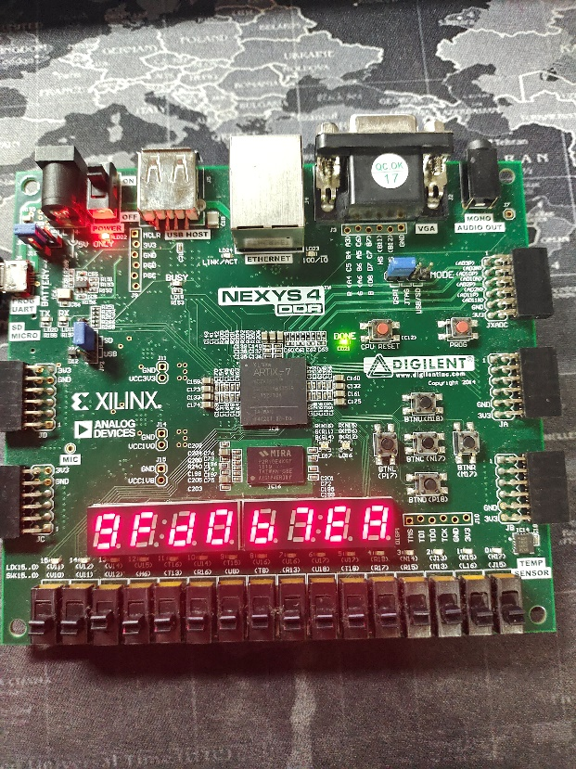

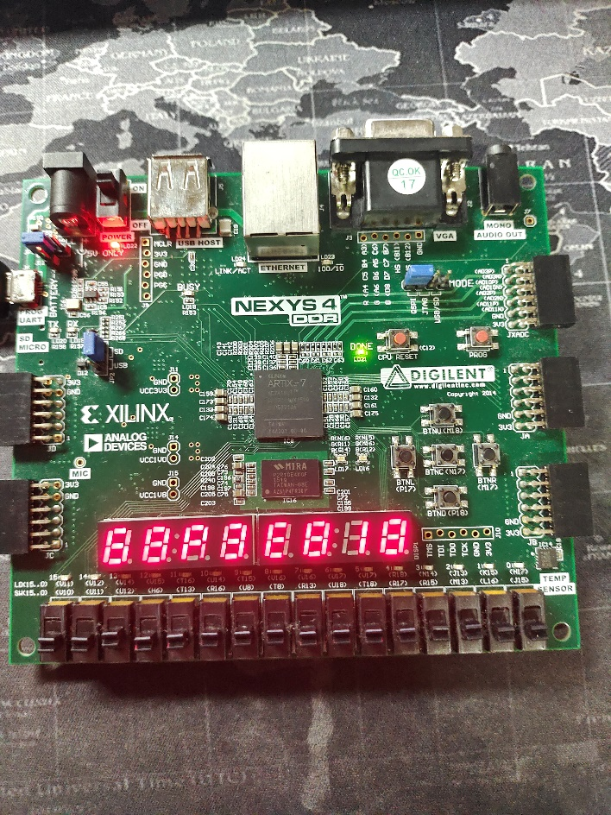

稳定在最后一个数组内容：

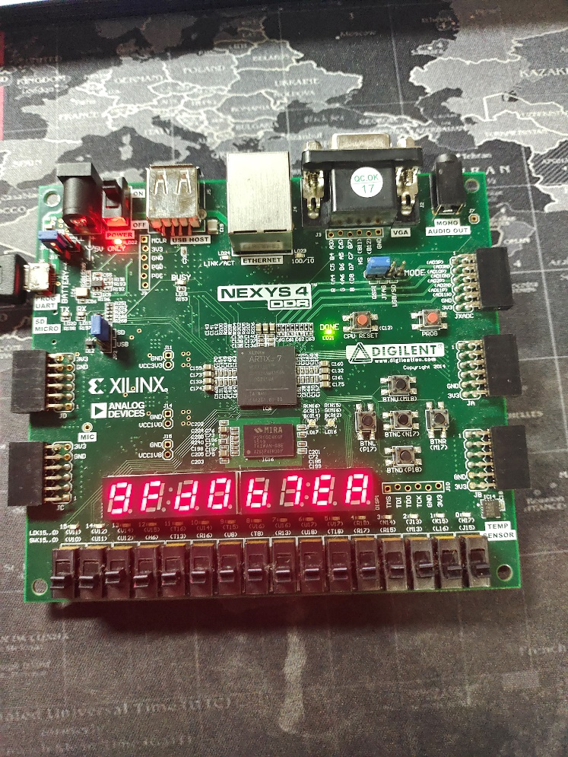

中断stop：

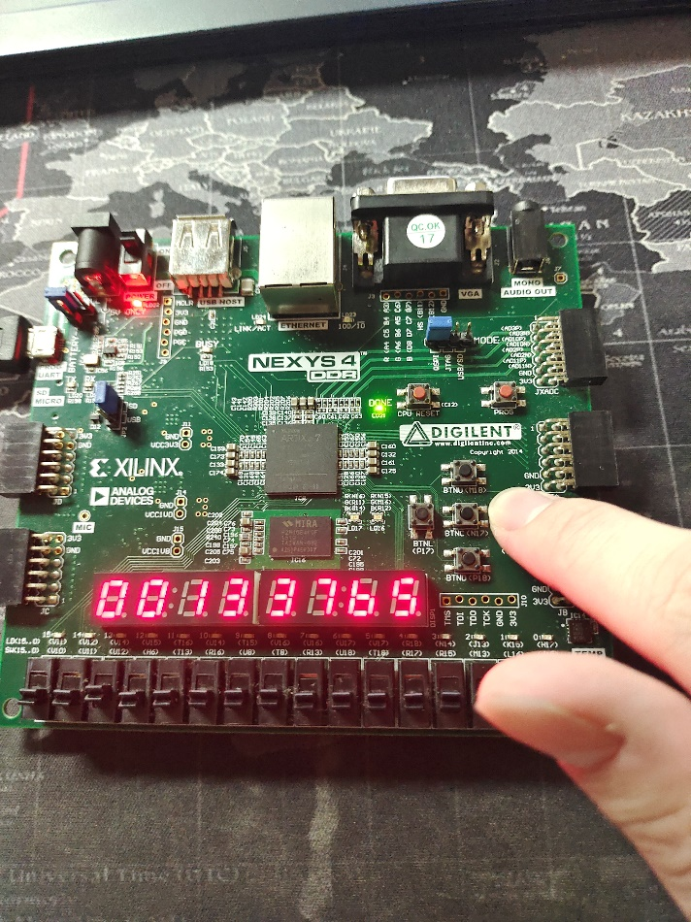

重置reset：

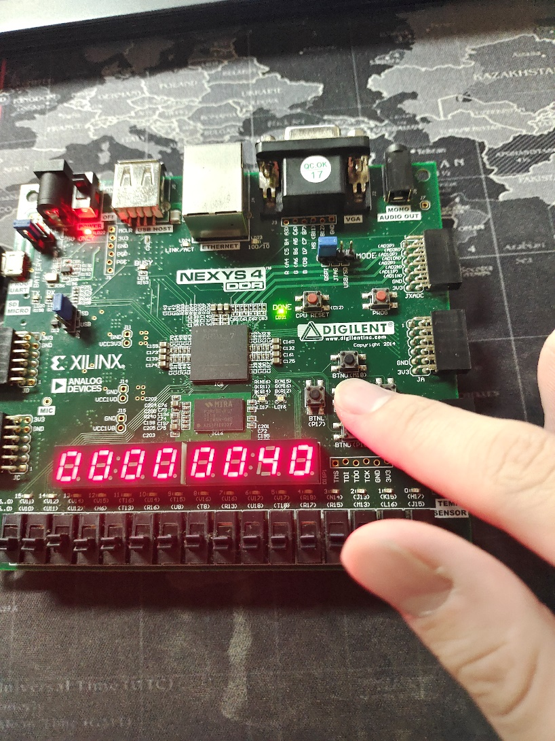

由上图可知下板后得到的实验结果和（六）中MARS得到的结果和仿真得到的结果相同，均为0x9fd0b7ea，因此可以证明下板结果是正确的。

1. **流水线的性能指标定性分析（包括：吞吐率、加速比、效率及相关与冲突分析）**

一．对动态流水线性能指标的定性分析：

1.数据相关

多条指令数据相关：根据指令的不同选择不同的解决方案。

（1）.采用数据前推的方法，使用专用路径来解决数据相关问题。绝大部分指令(ALU)在第三个周期(EX)就已经得出了结果，而需要取数据的一般只在第二个周期(ID)。因此，对ID-EX,ID-ME,ID-WB三个流水段进行专用路径的设置，应用于HILO寄存器和regfile寄存器堆上，具体实现如下：

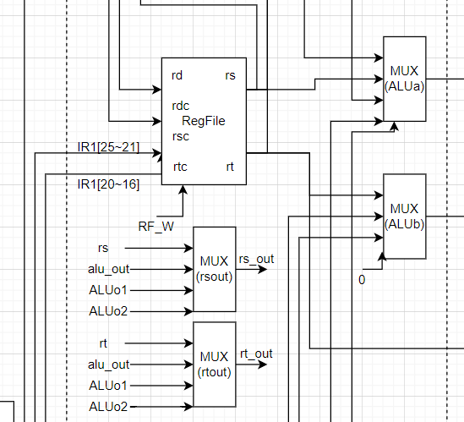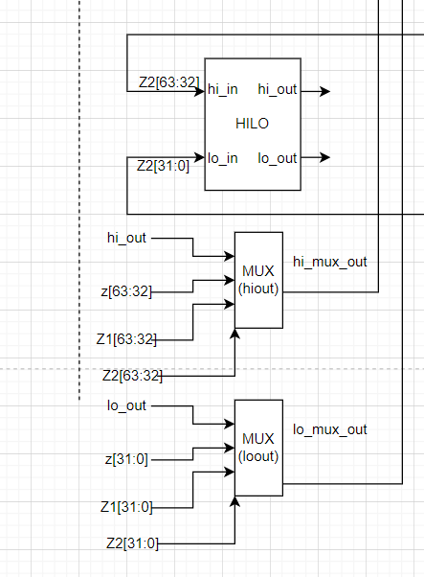

数据前推，流水线不暂停：



（2）.采用暂停流水线（在段间流水寄存器中插入空指令）的方法来解决数据相关问题。读寄存器出现在ID段，写寄存器出现在WB段，因此需要检测的数据冲突为ID-EX,ID-ME,ID-WB三个位置。这个方法只应用于跳转指令和内存读取指令。

由于数据相关而插入空指令的实例：



2.控制相关

对于J、JR、JAL、BEQ、BNE这几条分支和跳转指令，采用延迟槽的思想，并将其判断分支前移至ID级，使得分支延迟为一个周期。

当分支成功或者转移发生时，令处于延迟槽内的指令失效。

当分支失败或转移未发生时，延迟槽内的指令正常执行。

3.冲突

(1).数据冲突：利用数据前推和流水线暂停消除冲突。

(2).控制冲突：利用延迟槽技术消除冲突。

二．对动态流水线性能指标的定量分析：

MARS软件对（七）中汇编程序的统计结果如下：

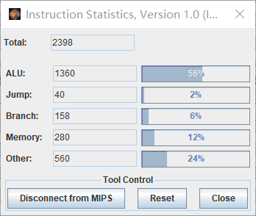

指令总数：2398条。

ALU指令：1360条，占比56%。

跳转指令：40条，占比2%。

分支指令：158条，占比6%。

内存读写指令：280条，占比12%。

其他指令：560条，占比24%。

寄存器中数据达到稳定的时间点：

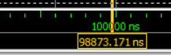

仿真得出结果总共用了98800ns，98800/40=2472时钟周期。

1．吞吐率

完成任务总共执行了2398条指令，耗费2472个时钟周期。因此计算所得的吞吐率为：

$$吞吐率=\frac{2398}{2472}=0.9701/时钟周期$$

2.加速比

顺序完成2398条指令所需要的时间为：(1360+40+560)*5+280*4+158*2=11236个时钟周期。实际用时为2472个时钟周期，所以加速比为：

$$加速比=\frac{11236个时钟周期}{2472个时钟周期}=4.545$$

3.效率

完成任务总共执行了2398条指令，指令顺序执行的周期数在上式中已经计算，为11236，因此得到：

$$效率=\frac{11236}{2472*5}*100\%=\frac{11236}{12360}*100\%=90.91\%$$

1. **总结与体会**

在本次计算机系统结构实验中，我完成了31+3条指令（包括mult、mfhi、mflo在内的三条额外指令）的动态流水线CPU设计、分析与验证。在设计方面，我按照流水段划分构建了动态流水线的总体结构，并具体列出了部件接口和控制信号。具体到每一个流水段的部件、输入、输出、功能都进行了列举分析。在CPU验证方面，我依次完成了前仿真，后仿真和具体的下板实验，通过测试动态流水线CPU所支持的coe，观察波形图并与标准输出文件相比较，从而验证CPU的功能正确实现。

同时，我直接使用汇编语言设计循环相乘求数组中内容的算法，同时利用MARS编译器生成MIPS指令集下的可执行目标程序（coe），并且成功进行了下板验证。最后，我对流水线的性能指标进行了定性分析，包括吞吐率、加速比、效率及相关与冲突分析、CPU的运行时间及存储器空间的使用等性能参数。

在实验的全过程中，我提高了自己对于动态流水线CPU具体内容和实现方法的认识，通过亲自实践一个完整的动态流水线CPU设计、分析与验证过程，巩固了在课上所学到的知识，增进了对系统结构相关内容的了解。除此以外，我对硬件电路设计、仿真流程、DEBUG工具的使用等方面也有了更进一步的了解。

1. **附件（所有程序）**

1.动态流水线的设计程序

module pc(

input PC_CLK,

input reset,

input wena,

input [31:0] pc_in,

output reg [31:0] pc_out

);

always @(negedge PC_CLK or posedge reset)//上升沿 or 下降沿？

begin

if(reset==1'b1)

pc_out<=32'h00400000;

else if(wena==1)

pc_out<=pc_in;

else

begin

//pc_out<=pc_in;

end

end

endmodule

module Regfiles(

input clk,

input rst,

input rf_w,

input [4:0]raddr1,

input [4:0]raddr2,

input [4:0]waddr,

input [31:0]wdata,

output reg [31:0]rdata1,

output reg [31:0]rdata2,

output reg [31:0] outreg1,

output reg [31:0] outreg2

);

reg [31:0] array_reg [31:0];//reg数组,前面为位数，后面为数组元素个数

always @(*)

begin

outreg1=array_reg[11];

outreg2=array_reg[12];

end

always @(negedge clk or posedge rst)

begin

if(rst==1'b1)

begin

array_reg[0]=32'b0;

array_reg[1]=32'b0;

array_reg[2]=32'b0;

array_reg[3]=32'b0;

array_reg[4]=32'b0;

array_reg[5]=32'b0;

array_reg[6]=32'b0;

array_reg[7]=32'b0;

array_reg[8]=32'b0;

array_reg[9]=32'b0;

array_reg[10]=32'b0;

array_reg[11]=32'b0;

array_reg[12]=32'b0;

array_reg[13]=32'b0;

array_reg[14]=32'b0;

array_reg[15]=32'b0;

array_reg[16]=32'b0;

array_reg[17]=32'b0;

array_reg[18]=32'b0;

array_reg[19]=32'b0;

array_reg[20]=32'b0;

array_reg[21]=32'b0;

array_reg[22]=32'b0;

array_reg[23]=32'b0;

array_reg[24]=32'b0;

array_reg[25]=32'b0;

array_reg[26]=32'b0;

array_reg[27]=32'b0;

array_reg[28]=32'b0;

array_reg[29]=32'b0;

array_reg[30]=32'b0;

array_reg[31]=32'b0;

end

else

begin

if(rf_w==1)

begin

if (waddr == 0)

array_reg[0] = 0;

else if (waddr == 1)

array_reg[1] = wdata;

else if (waddr == 2)

array_reg[2] = wdata;

else if (waddr == 3)

array_reg[3] = wdata;

else if (waddr == 4)

array_reg[4] = wdata;

else if (waddr == 5)

array_reg[5] = wdata;

else if (waddr == 6)

array_reg[6] = wdata;

else if (waddr == 7)

array_reg[7] = wdata;

else if (waddr == 8)

array_reg[8] = wdata;

else if (waddr == 9)

array_reg[9] = wdata;

else if (waddr == 10)

array_reg[10] = wdata;

else if (waddr == 11)

array_reg[11] = wdata;

else if (waddr == 12)

array_reg[12] = wdata;

else if (waddr == 13)

array_reg[13] = wdata;

else if (waddr == 14)

array_reg[14] = wdata;

else if (waddr == 15)

array_reg[15] = wdata;

else if (waddr == 16)

array_reg[16] = wdata;

else if (waddr == 17)

array_reg[17] = wdata;

else if (waddr == 18)

array_reg[18] = wdata;

else if (waddr == 19)

array_reg[19] = wdata;

else if (waddr == 20)

array_reg[20] = wdata;

else if (waddr == 21)

array_reg[21] = wdata;

else if (waddr == 22)

array_reg[22] = wdata;

else if (waddr == 23)

array_reg[23] = wdata;

else if (waddr == 24)

array_reg[24] = wdata;

else if (waddr == 25)

array_reg[25] = wdata;

else if (waddr == 26)

array_reg[26] = wdata;

else if (waddr == 27)

array_reg[27] = wdata;

else if (waddr == 28)

array_reg[28] = wdata;

else if (waddr == 29)

array_reg[29] = wdata;

else if (waddr == 30)

array_reg[30] = wdata;

else if (waddr == 31)

array_reg[31] = wdata;

else

begin

end

end

else//rf_w==0

begin

end

end

end

always @(*)

begin

if(raddr1==0)

rdata1=array_reg[0];

else if(raddr1==1)

rdata1=array_reg[1];

else if(raddr1==2)

rdata1=array_reg[2];

else if(raddr1==3)

rdata1=array_reg[3];

else if(raddr1==4)

rdata1=array_reg[4];

else if(raddr1==5)

rdata1=array_reg[5];

else if(raddr1==6)

rdata1=array_reg[6];

else if(raddr1==7)

rdata1=array_reg[7];

else if(raddr1==8)

rdata1=array_reg[8];

else if(raddr1==9)

rdata1=array_reg[9];

else if(raddr1==10)

rdata1=array_reg[10];

else if(raddr1==11)

rdata1=array_reg[11];

else if(raddr1==12)

rdata1=array_reg[12];

else if(raddr1==13)

rdata1=array_reg[13];

else if(raddr1==14)

rdata1=array_reg[14];

else if(raddr1==15)

rdata1=array_reg[15];

else if(raddr1==16)

rdata1=array_reg[16];

else if(raddr1==17)

rdata1=array_reg[17];

else if(raddr1==18)

rdata1=array_reg[18];

else if(raddr1==19)

rdata1=array_reg[19];

else if(raddr1==20)

rdata1=array_reg[20];

else if(raddr1==21)

rdata1=array_reg[21];

else if(raddr1==22)

rdata1=array_reg[22];

else if(raddr1==23)

rdata1=array_reg[23];

else if(raddr1==24)

rdata1=array_reg[24];

else if(raddr1==25)

rdata1=array_reg[25];

else if(raddr1==26)

rdata1=array_reg[26];

else if(raddr1==27)

rdata1=array_reg[27];

else if(raddr1==28)

rdata1=array_reg[28];

else if(raddr1==29)

rdata1=array_reg[29];

else if(raddr1==30)

rdata1=array_reg[30];

else if(raddr1==31)

rdata1=array_reg[31];

else

begin

end

if(raddr2==0)

rdata2=array_reg[0];

else if(raddr2==1)

rdata2=array_reg[1];

else if(raddr2==2)

rdata2=array_reg[2];

else if(raddr2==3)

rdata2=array_reg[3];

else if(raddr2==4)

rdata2=array_reg[4];

else if(raddr2==5)

rdata2=array_reg[5];

else if(raddr2==6)

rdata2=array_reg[6];

else if(raddr2==7)

rdata2=array_reg[7];

else if(raddr2==8)

rdata2=array_reg[8];

else if(raddr2==9)

rdata2=array_reg[9];

else if(raddr2==10)

rdata2=array_reg[10];

else if(raddr2==11)

rdata2=array_reg[11];

else if(raddr2==12)

rdata2=array_reg[12];

else if(raddr2==13)

rdata2=array_reg[13];

else if(raddr2==14)

rdata2=array_reg[14];

else if(raddr2==15)

rdata2=array_reg[15];

else if(raddr2==16)

rdata2=array_reg[16];

else if(raddr2==17)

rdata2=array_reg[17];

else if(raddr2==18)

rdata2=array_reg[18];

else if(raddr2==19)

rdata2=array_reg[19];

else if(raddr2==20)

rdata2=array_reg[20];

else if(raddr2==21)

rdata2=array_reg[21];

else if(raddr2==22)

rdata2=array_reg[22];

else if(raddr2==23)

rdata2=array_reg[23];

else if(raddr2==24)

rdata2=array_reg[24];

else if(raddr2==25)

rdata2=array_reg[25];

else if(raddr2==26)

rdata2=array_reg[26];

else if(raddr2==27)

rdata2=array_reg[27];

else if(raddr2==28)

rdata2=array_reg[28];

else if(raddr2==29)

rdata2=array_reg[29];

else if(raddr2==30)

rdata2=array_reg[30];

else if(raddr2==31)

rdata2=array_reg[31];

else

begin

end

end

endmodule

module ADD(

input [31:0]a,

input [31:0]b,

output [31:0]c

);

assign c=a+b;

endmodule

module alu(

input [31:0] a,

input [31:0] b,

input [3:0] aluc,

input reset,

output reg [31:0] r,

output reg zero,

output reg carry,

output reg negative,

output reg overflow

);

reg [31:0]kkk;

always @(*)

begin

if(reset==1'b1)

begin

r=32'b0;

zero=0;

carry=0;

negative=0;

overflow=0;

end

else

begin

if (aluc == 4'b0000)

begin

r=a+b;

if(r==0)

zero=1;

else

zero=0;

if(r<a||r<b)

carry=1;

else

carry=0;

if(r[31]==1)

negative=1;

else

negative=0;

end

else if (aluc == 4'b0010)

begin

r=a+b;

if(r==0)

zero=1;

else

zero=0;

if(r[31]==1)

negative=1;

else

negative=0;

if((a[31]==0&&b[31]==0&&r[31]==1)||(a[31]==1&&b[31]==1&&r[31]==0))

overflow=1;

else

overflow=0;

end

else if (aluc == 4'b0001)

begin

r=a-b;

if(r==0)

zero=1;

else

zero=0;

if(r>a)

carry=1;

else

carry=0;

if(r[31]==1)

negative=1;

else

negative=0;

end

else if (aluc == 4'b0011)

begin

r=a-b;

if(r==0)

zero=1;

else

zero=0;

if(r[31]==1)

negative=1;

else

negative=0;

if((a[31]==0&&b[31]==1&&r[31]==1)||(a[31]==1&&b[31]==0&&r[31]==0))

overflow=1;

else

overflow=0;

end

else if (aluc == 4'b0100)

begin

r=a&b;

if(r==0)

zero=1;

else

zero=0;

if(r[31]==1)

negative=1;

else

negative=0;

end

else if (aluc == 4'b0101)

begin

r=a|b;

if(r==0)

zero=1;

else

zero=0;

if(r[31]==1)

negative=1;

else

negative=0;

end

else if (aluc == 4'b0110)

begin

r=a^b;

if(r==0)

zero=1;

else

zero=0;

if(r[31]==1)

negative=1;

else

negative=0;

end

else if (aluc == 4'b0111)

begin

r=~(a|b);

if(r==0)

zero=1;

else

zero=0;

if(r[31]==1)

negative=1;

else

negative=0;

end

else if (aluc == 4'b1000||aluc == 4'b1001)

begin

r={b[15:0],16'b0};

if(r==0)

zero=1;

else

zero=0;

if(r[31]==1)

negative=1;

else

negative=0;

end

else if (aluc == 4'b1011)

begin

// r=(a<b)?1:0;

if(a[31]==0&&b[31]==0)

r=(a<b)?1:0;

else if(a[31]==0&&b[31]==1)

r=0;

else if(a[31]==1&&b[31]==0)

r=1;

else

r=(a<b)?1:0;

if(a-b==0)

zero=1;

else

zero=0;

kkk=a-b;

if(kkk[31]==1)

negative=1;

else

negative=0;

end

else if (aluc == 4'b1010)

begin

r=(a<b)?1:0;

if(a-b==0)

zero=1;

else

zero=0;

if(a<b)

carry=1;

else

carry=0;

if(r[31]==1)

negative=1;

else

negative=0;

end

else if (aluc == 4'b1100)

begin

// r=b>>>a;

r=($signed(b)) >>> a;

if(r==0)

zero=1;

else

zero=0;

if(a==0)

carry=0;

else if(a<=32)

carry=b[a-1];

else

carry=b[31];

//carry=

if(r[31]==1)

negative=1;

else

negative=0;

end

else if (aluc == 4'b1110)

begin

r=b<<a;

if(r==0)

zero=1;

else

zero=0;

if(a==0)

carry=0;

else if(a<=32)

carry=b[32-a];

else

carry=0;

if(r[31]==1)

negative=1;

else

negative=0;

end

else if (aluc == 4'b1111)//原样传值，额外添加，用于mfhi,mflo操作中。

begin

r=a;

end

else if (aluc == 4'b1101)

begin

r=b>>a;

if(r==0)

zero=1;

else

zero=0;

if(a==0)

carry=0;

else if(a<=32)

carry=b[a-1];

else

carry=0;

//carry=

if(r[31]==1)

negative=1;

else

negative=0;

end

else

begin

end

end

end

endmodule

module controller(

/*段间流水指令寄存器*/

input rst,

input [31:0] if_Instr,

input [31:0] id_Instr,

input [31:0] ex_Instr,

input [31:0] me_Instr,

input [31:0] wb_Instr,

input equal,//相等为1，不相等为0

/*ALU状态信号，决定是否写入等操作*/

/*input me_Z,

input me_C,

input me_N,

input me_O,

input wb_Z,

input wb_C,

input wb_N,

input wb_O,*/

output RF_W,

output [3:0] ALUC,//alu识别码

/*选择器*/

output [1:0] PCMux,

output [2:0] ALUaMux,

output [1:0] ALUbMux,

output rdMux,

output [1:0] rdcMux,

/*dmem信号*/

output CS,

output DM_R,

output DM_W,

output reg [4:0] stall,

/*动态流水线新增加控制信号,后两个和数据冲突相关*/

output HI_W,

output LO_W,

output reg [1:0] rsoutMux,

output reg [1:0] rtoutMux,

output reg [1:0] hioutMux,

output reg [1:0] looutMux

);

/*主体思想：分段指令译码，每一个流水段间的译码过程相同（整体替换关键字即可）*/

//定义id分段的指令译码

wire [5:0] id_op = id_Instr[31:26];

wire [5:0] id_func = id_Instr[5:0];

//指令种类，组合逻辑构建

wire id_add,id_addi,id_addu,id_addiu,id_sub,id_subu;

wire id_and,id_andi,id_or,id_ori,id_xor,id_xori,id_nor;

wire id_lui;

wire id_sll,id_sllv,id_sra,id_srav,id_srl,id_srlv;

wire id_slt,id_slti,id_sltu,id_sltiu;

wire id_beq,id_bne;

wire id_j,id_jal,id_jr;

wire id_lw,id_sw;

wire id_mult,id_mflo,id_mfhi;

//R-TYPE

assign id_add=(~id_op[5])&(~id_op[4])&(~id_op[3])&(~id_op[2])&(~id_op[1])&(~id_op[0])&(id_func[5])&(~id_func[4])&(~id_func[3])&(~id_func[2])&(~id_func[1])&(~id_func[0]);

assign id_addu=(~id_op[5])&(~id_op[4])&(~id_op[3])&(~id_op[2])&(~id_op[1])&(~id_op[0])&(id_func[5])&(~id_func[4])&(~id_func[3])&(~id_func[2])&(~id_func[1])&(id_func[0]);

assign id_sub=(~id_op[5])&(~id_op[4])&(~id_op[3])&(~id_op[2])&(~id_op[1])&(~id_op[0])&(id_func[5])&(~id_func[4])&(~id_func[3])&(~id_func[2])&(id_func[1])&(~id_func[0]);

assign id_subu=(~id_op[5])&(~id_op[4])&(~id_op[3])&(~id_op[2])&(~id_op[1])&(~id_op[0])&(id_func[5])&(~id_func[4])&(~id_func[3])&(~id_func[2])&(id_func[1])&(id_func[0]);

assign id_and=(~id_op[5])&(~id_op[4])&(~id_op[3])&(~id_op[2])&(~id_op[1])&(~id_op[0])&(id_func[5])&(~id_func[4])&(~id_func[3])&(id_func[2])&(~id_func[1])&(~id_func[0]);

assign id_or=(~id_op[5])&(~id_op[4])&(~id_op[3])&(~id_op[2])&(~id_op[1])&(~id_op[0])&(id_func[5])&(~id_func[4])&(~id_func[3])&(id_func[2])&(~id_func[1])&(id_func[0]);

assign id_xor=(~id_op[5])&(~id_op[4])&(~id_op[3])&(~id_op[2])&(~id_op[1])&(~id_op[0])&(id_func[5])&(~id_func[4])&(~id_func[3])&(id_func[2])&(id_func[1])&(~id_func[0]);

assign id_nor=(~id_op[5])&(~id_op[4])&(~id_op[3])&(~id_op[2])&(~id_op[1])&(~id_op[0])&(id_func[5])&(~id_func[4])&(~id_func[3])&(id_func[2])&(id_func[1])&(id_func[0]);

assign id_slt=(~id_op[5])&(~id_op[4])&(~id_op[3])&(~id_op[2])&(~id_op[1])&(~id_op[0])&(id_func[5])&(~id_func[4])&(id_func[3])&(~id_func[2])&(id_func[1])&(~id_func[0]);

assign id_sltu=(~id_op[5])&(~id_op[4])&(~id_op[3])&(~id_op[2])&(~id_op[1])&(~id_op[0])&(id_func[5])&(~id_func[4])&(id_func[3])&(~id_func[2])&(id_func[1])&(id_func[0]);

assign id_sll=(~id_op[5])&(~id_op[4])&(~id_op[3])&(~id_op[2])&(~id_op[1])&(~id_op[0])&(~id_func[5])&(~id_func[4])&(~id_func[3])&(~id_func[2])&(~id_func[1])&(~id_func[0]);

assign id_srl=(~id_op[5])&(~id_op[4])&(~id_op[3])&(~id_op[2])&(~id_op[1])&(~id_op[0])&(~id_func[5])&(~id_func[4])&(~id_func[3])&(~id_func[2])&(id_func[1])&(~id_func[0]);

assign id_sra=(~id_op[5])&(~id_op[4])&(~id_op[3])&(~id_op[2])&(~id_op[1])&(~id_op[0])&(~id_func[5])&(~id_func[4])&(~id_func[3])&(~id_func[2])&(id_func[1])&(id_func[0]);

assign id_sllv=(~id_op[5])&(~id_op[4])&(~id_op[3])&(~id_op[2])&(~id_op[1])&(~id_op[0])&(~id_func[5])&(~id_func[4])&(~id_func[3])&(id_func[2])&(~id_func[1])&(~id_func[0]);

assign id_srlv=(~id_op[5])&(~id_op[4])&(~id_op[3])&(~id_op[2])&(~id_op[1])&(~id_op[0])&(~id_func[5])&(~id_func[4])&(~id_func[3])&(id_func[2])&(id_func[1])&(~id_func[0]);

assign id_srav=(~id_op[5])&(~id_op[4])&(~id_op[3])&(~id_op[2])&(~id_op[1])&(~id_op[0])&(~id_func[5])&(~id_func[4])&(~id_func[3])&(id_func[2])&(id_func[1])&(id_func[0]);

assign id_jr=(~id_op[5])&(~id_op[4])&(~id_op[3])&(~id_op[2])&(~id_op[1])&(~id_op[0])&(~id_func[5])&(~id_func[4])&(id_func[3])&(~id_func[2])&(~id_func[1])&(~id_func[0]);

//I-TYPE

assign id_addi=(~id_op[5])&(~id_op[4])&(id_op[3])&(~id_op[2])&(~id_op[1])&(~id_op[0]);

assign id_addiu=(~id_op[5])&(~id_op[4])&(id_op[3])&(~id_op[2])&(~id_op[1])&(id_op[0]);

assign id_andi=(~id_op[5])&(~id_op[4])&(id_op[3])&(id_op[2])&(~id_op[1])&(~id_op[0]);

assign id_ori=(~id_op[5])&(~id_op[4])&(id_op[3])&(id_op[2])&(~id_op[1])&(id_op[0]);

assign id_xori=(~id_op[5])&(~id_op[4])&(id_op[3])&(id_op[2])&(id_op[1])&(~id_op[0]);

assign id_lui=(~id_op[5])&(~id_op[4])&(id_op[3])&(id_op[2])&(id_op[1])&(id_op[0]);

assign id_lw=(id_op[5])&(~id_op[4])&(~id_op[3])&(~id_op[2])&(id_op[1])&(id_op[0]);

assign id_sw=(id_op[5])&(~id_op[4])&(id_op[3])&(~id_op[2])&(id_op[1])&(id_op[0]);

assign id_beq=(~id_op[5])&(~id_op[4])&(~id_op[3])&(id_op[2])&(~id_op[1])&(~id_op[0]);

assign id_bne=(~id_op[5])&(~id_op[4])&(~id_op[3])&(id_op[2])&(~id_op[1])&(id_op[0]);

assign id_slti=(~id_op[5])&(~id_op[4])&(id_op[3])&(~id_op[2])&(id_op[1])&(~id_op[0]);

assign id_sltiu=(~id_op[5])&(~id_op[4])&(id_op[3])&(~id_op[2])&(id_op[1])&(id_op[0]);

//J-TYPE

assign id_j=(~id_op[5])&(~id_op[4])&(~id_op[3])&(~id_op[2])&(id_op[1])&(~id_op[0]);

assign id_jal=(~id_op[5])&(~id_op[4])&(~id_op[3])&(~id_op[2])&(id_op[1])&(id_op[0]);

//stall-TYPE

wire id_extra_stall;

assign id_extra_stall=(id_op[5])&(id_op[4])&(id_op[3])&(id_op[2])&(id_op[1])&(id_op[0]);

//dynamic-extra

assign id_mult=(~id_op[5])&(~id_op[4])&(~id_op[3])&(~id_op[2])&(~id_op[1])&(~id_op[0])&(~id_func[5])&(id_func[4])&(id_func[3])&(~id_func[2])&(~id_func[1])&(~id_func[0]);

assign id_mfhi=(~id_op[5])&(~id_op[4])&(~id_op[3])&(~id_op[2])&(~id_op[1])&(~id_op[0])&(~id_func[5])&(id_func[4])&(~id_func[3])&(~id_func[2])&(~id_func[1])&(~id_func[0]);

assign id_mflo=(~id_op[5])&(~id_op[4])&(~id_op[3])&(~id_op[2])&(~id_op[1])&(~id_op[0])&(~id_func[5])&(id_func[4])&(~id_func[3])&(~id_func[2])&(id_func[1])&(~id_func[0]);

//定义ex分段的指令译码

wire [5:0] ex_op = ex_Instr[31:26];

wire [5:0] ex_func = ex_Instr[5:0];

//指令种类，组合逻辑构建

wire ex_add,ex_addi,ex_addu,ex_addiu,ex_sub,ex_subu;

wire ex_and,ex_andi,ex_or,ex_ori,ex_xor,ex_xori,ex_nor;

wire ex_lui;

wire ex_sll,ex_sllv,ex_sra,ex_srav,ex_srl,ex_srlv;

wire ex_slt,ex_slti,ex_sltu,ex_sltiu;

wire ex_beq,ex_bne;

wire ex_j,ex_jal,ex_jr;

wire ex_lw,ex_sw;

wire ex_mult,ex_mflo,ex_mfhi;

//R-TYPE

assign ex_add=(~ex_op[5])&(~ex_op[4])&(~ex_op[3])&(~ex_op[2])&(~ex_op[1])&(~ex_op[0])&(ex_func[5])&(~ex_func[4])&(~ex_func[3])&(~ex_func[2])&(~ex_func[1])&(~ex_func[0]);

assign ex_addu=(~ex_op[5])&(~ex_op[4])&(~ex_op[3])&(~ex_op[2])&(~ex_op[1])&(~ex_op[0])&(ex_func[5])&(~ex_func[4])&(~ex_func[3])&(~ex_func[2])&(~ex_func[1])&(ex_func[0]);

assign ex_sub=(~ex_op[5])&(~ex_op[4])&(~ex_op[3])&(~ex_op[2])&(~ex_op[1])&(~ex_op[0])&(ex_func[5])&(~ex_func[4])&(~ex_func[3])&(~ex_func[2])&(ex_func[1])&(~ex_func[0]);

assign ex_subu=(~ex_op[5])&(~ex_op[4])&(~ex_op[3])&(~ex_op[2])&(~ex_op[1])&(~ex_op[0])&(ex_func[5])&(~ex_func[4])&(~ex_func[3])&(~ex_func[2])&(ex_func[1])&(ex_func[0]);

assign ex_and=(~ex_op[5])&(~ex_op[4])&(~ex_op[3])&(~ex_op[2])&(~ex_op[1])&(~ex_op[0])&(ex_func[5])&(~ex_func[4])&(~ex_func[3])&(ex_func[2])&(~ex_func[1])&(~ex_func[0]);

assign ex_or=(~ex_op[5])&(~ex_op[4])&(~ex_op[3])&(~ex_op[2])&(~ex_op[1])&(~ex_op[0])&(ex_func[5])&(~ex_func[4])&(~ex_func[3])&(ex_func[2])&(~ex_func[1])&(ex_func[0]);

assign ex_xor=(~ex_op[5])&(~ex_op[4])&(~ex_op[3])&(~ex_op[2])&(~ex_op[1])&(~ex_op[0])&(ex_func[5])&(~ex_func[4])&(~ex_func[3])&(ex_func[2])&(ex_func[1])&(~ex_func[0]);

assign ex_nor=(~ex_op[5])&(~ex_op[4])&(~ex_op[3])&(~ex_op[2])&(~ex_op[1])&(~ex_op[0])&(ex_func[5])&(~ex_func[4])&(~ex_func[3])&(ex_func[2])&(ex_func[1])&(ex_func[0]);

assign ex_slt=(~ex_op[5])&(~ex_op[4])&(~ex_op[3])&(~ex_op[2])&(~ex_op[1])&(~ex_op[0])&(ex_func[5])&(~ex_func[4])&(ex_func[3])&(~ex_func[2])&(ex_func[1])&(~ex_func[0]);

assign ex_sltu=(~ex_op[5])&(~ex_op[4])&(~ex_op[3])&(~ex_op[2])&(~ex_op[1])&(~ex_op[0])&(ex_func[5])&(~ex_func[4])&(ex_func[3])&(~ex_func[2])&(ex_func[1])&(ex_func[0]);

assign ex_sll=(~ex_op[5])&(~ex_op[4])&(~ex_op[3])&(~ex_op[2])&(~ex_op[1])&(~ex_op[0])&(~ex_func[5])&(~ex_func[4])&(~ex_func[3])&(~ex_func[2])&(~ex_func[1])&(~ex_func[0]);

assign ex_srl=(~ex_op[5])&(~ex_op[4])&(~ex_op[3])&(~ex_op[2])&(~ex_op[1])&(~ex_op[0])&(~ex_func[5])&(~ex_func[4])&(~ex_func[3])&(~ex_func[2])&(ex_func[1])&(~ex_func[0]);

assign ex_sra=(~ex_op[5])&(~ex_op[4])&(~ex_op[3])&(~ex_op[2])&(~ex_op[1])&(~ex_op[0])&(~ex_func[5])&(~ex_func[4])&(~ex_func[3])&(~ex_func[2])&(ex_func[1])&(ex_func[0]);

assign ex_sllv=(~ex_op[5])&(~ex_op[4])&(~ex_op[3])&(~ex_op[2])&(~ex_op[1])&(~ex_op[0])&(~ex_func[5])&(~ex_func[4])&(~ex_func[3])&(ex_func[2])&(~ex_func[1])&(~ex_func[0]);

assign ex_srlv=(~ex_op[5])&(~ex_op[4])&(~ex_op[3])&(~ex_op[2])&(~ex_op[1])&(~ex_op[0])&(~ex_func[5])&(~ex_func[4])&(~ex_func[3])&(ex_func[2])&(ex_func[1])&(~ex_func[0]);

assign ex_srav=(~ex_op[5])&(~ex_op[4])&(~ex_op[3])&(~ex_op[2])&(~ex_op[1])&(~ex_op[0])&(~ex_func[5])&(~ex_func[4])&(~ex_func[3])&(ex_func[2])&(ex_func[1])&(ex_func[0]);

assign ex_jr=(~ex_op[5])&(~ex_op[4])&(~ex_op[3])&(~ex_op[2])&(~ex_op[1])&(~ex_op[0])&(~ex_func[5])&(~ex_func[4])&(ex_func[3])&(~ex_func[2])&(~ex_func[1])&(~ex_func[0]);

//I-TYPE

assign ex_addi=(~ex_op[5])&(~ex_op[4])&(ex_op[3])&(~ex_op[2])&(~ex_op[1])&(~ex_op[0]);

assign ex_addiu=(~ex_op[5])&(~ex_op[4])&(ex_op[3])&(~ex_op[2])&(~ex_op[1])&(ex_op[0]);

assign ex_andi=(~ex_op[5])&(~ex_op[4])&(ex_op[3])&(ex_op[2])&(~ex_op[1])&(~ex_op[0]);

assign ex_ori=(~ex_op[5])&(~ex_op[4])&(ex_op[3])&(ex_op[2])&(~ex_op[1])&(ex_op[0]);

assign ex_xori=(~ex_op[5])&(~ex_op[4])&(ex_op[3])&(ex_op[2])&(ex_op[1])&(~ex_op[0]);

assign ex_lui=(~ex_op[5])&(~ex_op[4])&(ex_op[3])&(ex_op[2])&(ex_op[1])&(ex_op[0]);

assign ex_lw=(ex_op[5])&(~ex_op[4])&(~ex_op[3])&(~ex_op[2])&(ex_op[1])&(ex_op[0]);

assign ex_sw=(ex_op[5])&(~ex_op[4])&(ex_op[3])&(~ex_op[2])&(ex_op[1])&(ex_op[0]);

assign ex_beq=(~ex_op[5])&(~ex_op[4])&(~ex_op[3])&(ex_op[2])&(~ex_op[1])&(~ex_op[0]);

assign ex_bne=(~ex_op[5])&(~ex_op[4])&(~ex_op[3])&(ex_op[2])&(~ex_op[1])&(ex_op[0]);

assign ex_slti=(~ex_op[5])&(~ex_op[4])&(ex_op[3])&(~ex_op[2])&(ex_op[1])&(~ex_op[0]);

assign ex_sltiu=(~ex_op[5])&(~ex_op[4])&(ex_op[3])&(~ex_op[2])&(ex_op[1])&(ex_op[0]);

//J-TYPE

assign ex_j=(~ex_op[5])&(~ex_op[4])&(~ex_op[3])&(~ex_op[2])&(ex_op[1])&(~ex_op[0]);

assign ex_jal=(~ex_op[5])&(~ex_op[4])&(~ex_op[3])&(~ex_op[2])&(ex_op[1])&(ex_op[0]);

//stall-TYPE

wire ex_extra_stall;

assign ex_extra_stall=(ex_op[5])&(ex_op[4])&(ex_op[3])&(ex_op[2])&(ex_op[1])&(ex_op[0]);

//dynamic-extra

assign ex_mult=(~ex_op[5])&(~ex_op[4])&(~ex_op[3])&(~ex_op[2])&(~ex_op[1])&(~ex_op[0])&(~ex_func[5])&(ex_func[4])&(ex_func[3])&(~ex_func[2])&(~ex_func[1])&(~ex_func[0]);

assign ex_mfhi=(~ex_op[5])&(~ex_op[4])&(~ex_op[3])&(~ex_op[2])&(~ex_op[1])&(~ex_op[0])&(~ex_func[5])&(ex_func[4])&(~ex_func[3])&(~ex_func[2])&(~ex_func[1])&(~ex_func[0]);

assign ex_mflo=(~ex_op[5])&(~ex_op[4])&(~ex_op[3])&(~ex_op[2])&(~ex_op[1])&(~ex_op[0])&(~ex_func[5])&(ex_func[4])&(~ex_func[3])&(~ex_func[2])&(ex_func[1])&(~ex_func[0]);

//定义me分段的指令译码

wire [5:0] me_op = me_Instr[31:26];

wire [5:0] me_func = me_Instr[5:0];

//指令种类，组合逻辑构建

wire me_add,me_addi,me_addu,me_addiu,me_sub,me_subu;

wire me_and,me_andi,me_or,me_ori,me_xor,me_xori,me_nor;

wire me_lui;

wire me_sll,me_sllv,me_sra,me_srav,me_srl,me_srlv;

wire me_slt,me_slti,me_sltu,me_sltiu;

wire me_beq,me_bne;

wire me_j,me_jal,me_jr;

wire me_lw,me_sw;

wire me_mult,me_mflo,me_mfhi;

//R-TYPE

assign me_add=(~me_op[5])&(~me_op[4])&(~me_op[3])&(~me_op[2])&(~me_op[1])&(~me_op[0])&(me_func[5])&(~me_func[4])&(~me_func[3])&(~me_func[2])&(~me_func[1])&(~me_func[0]);

assign me_addu=(~me_op[5])&(~me_op[4])&(~me_op[3])&(~me_op[2])&(~me_op[1])&(~me_op[0])&(me_func[5])&(~me_func[4])&(~me_func[3])&(~me_func[2])&(~me_func[1])&(me_func[0]);

assign me_sub=(~me_op[5])&(~me_op[4])&(~me_op[3])&(~me_op[2])&(~me_op[1])&(~me_op[0])&(me_func[5])&(~me_func[4])&(~me_func[3])&(~me_func[2])&(me_func[1])&(~me_func[0]);

assign me_subu=(~me_op[5])&(~me_op[4])&(~me_op[3])&(~me_op[2])&(~me_op[1])&(~me_op[0])&(me_func[5])&(~me_func[4])&(~me_func[3])&(~me_func[2])&(me_func[1])&(me_func[0]);

assign me_and=(~me_op[5])&(~me_op[4])&(~me_op[3])&(~me_op[2])&(~me_op[1])&(~me_op[0])&(me_func[5])&(~me_func[4])&(~me_func[3])&(me_func[2])&(~me_func[1])&(~me_func[0]);

assign me_or=(~me_op[5])&(~me_op[4])&(~me_op[3])&(~me_op[2])&(~me_op[1])&(~me_op[0])&(me_func[5])&(~me_func[4])&(~me_func[3])&(me_func[2])&(~me_func[1])&(me_func[0]);

assign me_xor=(~me_op[5])&(~me_op[4])&(~me_op[3])&(~me_op[2])&(~me_op[1])&(~me_op[0])&(me_func[5])&(~me_func[4])&(~me_func[3])&(me_func[2])&(me_func[1])&(~me_func[0]);

assign me_nor=(~me_op[5])&(~me_op[4])&(~me_op[3])&(~me_op[2])&(~me_op[1])&(~me_op[0])&(me_func[5])&(~me_func[4])&(~me_func[3])&(me_func[2])&(me_func[1])&(me_func[0]);

assign me_slt=(~me_op[5])&(~me_op[4])&(~me_op[3])&(~me_op[2])&(~me_op[1])&(~me_op[0])&(me_func[5])&(~me_func[4])&(me_func[3])&(~me_func[2])&(me_func[1])&(~me_func[0]);

assign me_sltu=(~me_op[5])&(~me_op[4])&(~me_op[3])&(~me_op[2])&(~me_op[1])&(~me_op[0])&(me_func[5])&(~me_func[4])&(me_func[3])&(~me_func[2])&(me_func[1])&(me_func[0]);

assign me_sll=(~me_op[5])&(~me_op[4])&(~me_op[3])&(~me_op[2])&(~me_op[1])&(~me_op[0])&(~me_func[5])&(~me_func[4])&(~me_func[3])&(~me_func[2])&(~me_func[1])&(~me_func[0]);

assign me_srl=(~me_op[5])&(~me_op[4])&(~me_op[3])&(~me_op[2])&(~me_op[1])&(~me_op[0])&(~me_func[5])&(~me_func[4])&(~me_func[3])&(~me_func[2])&(me_func[1])&(~me_func[0]);

assign me_sra=(~me_op[5])&(~me_op[4])&(~me_op[3])&(~me_op[2])&(~me_op[1])&(~me_op[0])&(~me_func[5])&(~me_func[4])&(~me_func[3])&(~me_func[2])&(me_func[1])&(me_func[0]);

assign me_sllv=(~me_op[5])&(~me_op[4])&(~me_op[3])&(~me_op[2])&(~me_op[1])&(~me_op[0])&(~me_func[5])&(~me_func[4])&(~me_func[3])&(me_func[2])&(~me_func[1])&(~me_func[0]);

assign me_srlv=(~me_op[5])&(~me_op[4])&(~me_op[3])&(~me_op[2])&(~me_op[1])&(~me_op[0])&(~me_func[5])&(~me_func[4])&(~me_func[3])&(me_func[2])&(me_func[1])&(~me_func[0]);

assign me_srav=(~me_op[5])&(~me_op[4])&(~me_op[3])&(~me_op[2])&(~me_op[1])&(~me_op[0])&(~me_func[5])&(~me_func[4])&(~me_func[3])&(me_func[2])&(me_func[1])&(me_func[0]);

assign me_jr=(~me_op[5])&(~me_op[4])&(~me_op[3])&(~me_op[2])&(~me_op[1])&(~me_op[0])&(~me_func[5])&(~me_func[4])&(me_func[3])&(~me_func[2])&(~me_func[1])&(~me_func[0]);

//I-TYPE

assign me_addi=(~me_op[5])&(~me_op[4])&(me_op[3])&(~me_op[2])&(~me_op[1])&(~me_op[0]);

assign me_addiu=(~me_op[5])&(~me_op[4])&(me_op[3])&(~me_op[2])&(~me_op[1])&(me_op[0]);

assign me_andi=(~me_op[5])&(~me_op[4])&(me_op[3])&(me_op[2])&(~me_op[1])&(~me_op[0]);

assign me_ori=(~me_op[5])&(~me_op[4])&(me_op[3])&(me_op[2])&(~me_op[1])&(me_op[0]);

assign me_xori=(~me_op[5])&(~me_op[4])&(me_op[3])&(me_op[2])&(me_op[1])&(~me_op[0]);

assign me_lui=(~me_op[5])&(~me_op[4])&(me_op[3])&(me_op[2])&(me_op[1])&(me_op[0]);

assign me_lw=(me_op[5])&(~me_op[4])&(~me_op[3])&(~me_op[2])&(me_op[1])&(me_op[0]);

assign me_sw=(me_op[5])&(~me_op[4])&(me_op[3])&(~me_op[2])&(me_op[1])&(me_op[0]);

assign me_beq=(~me_op[5])&(~me_op[4])&(~me_op[3])&(me_op[2])&(~me_op[1])&(~me_op[0]);

assign me_bne=(~me_op[5])&(~me_op[4])&(~me_op[3])&(me_op[2])&(~me_op[1])&(me_op[0]);

assign me_slti=(~me_op[5])&(~me_op[4])&(me_op[3])&(~me_op[2])&(me_op[1])&(~me_op[0]);

assign me_sltiu=(~me_op[5])&(~me_op[4])&(me_op[3])&(~me_op[2])&(me_op[1])&(me_op[0]);

//J-TYPE

assign me_j=(~me_op[5])&(~me_op[4])&(~me_op[3])&(~me_op[2])&(me_op[1])&(~me_op[0]);

assign me_jal=(~me_op[5])&(~me_op[4])&(~me_op[3])&(~me_op[2])&(me_op[1])&(me_op[0]);

//stall-TYPE

wire me_extra_stall;

assign me_extra_stall=(me_op[5])&(me_op[4])&(me_op[3])&(me_op[2])&(me_op[1])&(me_op[0]);

//dynamic-extra

assign me_mult=(~me_op[5])&(~me_op[4])&(~me_op[3])&(~me_op[2])&(~me_op[1])&(~me_op[0])&(~me_func[5])&(me_func[4])&(me_func[3])&(~me_func[2])&(~me_func[1])&(~me_func[0]);

assign me_mfhi=(~me_op[5])&(~me_op[4])&(~me_op[3])&(~me_op[2])&(~me_op[1])&(~me_op[0])&(~me_func[5])&(me_func[4])&(~me_func[3])&(~me_func[2])&(~me_func[1])&(~me_func[0]);

assign me_mflo=(~me_op[5])&(~me_op[4])&(~me_op[3])&(~me_op[2])&(~me_op[1])&(~me_op[0])&(~me_func[5])&(me_func[4])&(~me_func[3])&(~me_func[2])&(me_func[1])&(~me_func[0]);

//定义ex分段的指令译码

wire [5:0] wb_op = wb_Instr[31:26];

wire [5:0] wb_func = wb_Instr[5:0];

//指令种类，组合逻辑构建

wire wb_add,wb_addi,wb_addu,wb_addiu,wb_sub,wb_subu;

wire wb_and,wb_andi,wb_or,wb_ori,wb_xor,wb_xori,wb_nor;

wire wb_lui;

wire wb_sll,wb_sllv,wb_sra,wb_srav,wb_srl,wb_srlv;

wire wb_slt,wb_slti,wb_sltu,wb_sltiu;

wire wb_beq,wb_bne;

wire wb_j,wb_jal,wb_jr;

wire wb_lw,wb_sw;

wire wb_mult,wb_mflo,wb_mfhi;

//R-TYPE

assign wb_add=(~wb_op[5])&(~wb_op[4])&(~wb_op[3])&(~wb_op[2])&(~wb_op[1])&(~wb_op[0])&(wb_func[5])&(~wb_func[4])&(~wb_func[3])&(~wb_func[2])&(~wb_func[1])&(~wb_func[0]);

assign wb_addu=(~wb_op[5])&(~wb_op[4])&(~wb_op[3])&(~wb_op[2])&(~wb_op[1])&(~wb_op[0])&(wb_func[5])&(~wb_func[4])&(~wb_func[3])&(~wb_func[2])&(~wb_func[1])&(wb_func[0]);

assign wb_sub=(~wb_op[5])&(~wb_op[4])&(~wb_op[3])&(~wb_op[2])&(~wb_op[1])&(~wb_op[0])&(wb_func[5])&(~wb_func[4])&(~wb_func[3])&(~wb_func[2])&(wb_func[1])&(~wb_func[0]);

assign wb_subu=(~wb_op[5])&(~wb_op[4])&(~wb_op[3])&(~wb_op[2])&(~wb_op[1])&(~wb_op[0])&(wb_func[5])&(~wb_func[4])&(~wb_func[3])&(~wb_func[2])&(wb_func[1])&(wb_func[0]);

assign wb_and=(~wb_op[5])&(~wb_op[4])&(~wb_op[3])&(~wb_op[2])&(~wb_op[1])&(~wb_op[0])&(wb_func[5])&(~wb_func[4])&(~wb_func[3])&(wb_func[2])&(~wb_func[1])&(~wb_func[0]);

assign wb_or=(~wb_op[5])&(~wb_op[4])&(~wb_op[3])&(~wb_op[2])&(~wb_op[1])&(~wb_op[0])&(wb_func[5])&(~wb_func[4])&(~wb_func[3])&(wb_func[2])&(~wb_func[1])&(wb_func[0]);

assign wb_xor=(~wb_op[5])&(~wb_op[4])&(~wb_op[3])&(~wb_op[2])&(~wb_op[1])&(~wb_op[0])&(wb_func[5])&(~wb_func[4])&(~wb_func[3])&(wb_func[2])&(wb_func[1])&(~wb_func[0]);

assign wb_nor=(~wb_op[5])&(~wb_op[4])&(~wb_op[3])&(~wb_op[2])&(~wb_op[1])&(~wb_op[0])&(wb_func[5])&(~wb_func[4])&(~wb_func[3])&(wb_func[2])&(wb_func[1])&(wb_func[0]);

assign wb_slt=(~wb_op[5])&(~wb_op[4])&(~wb_op[3])&(~wb_op[2])&(~wb_op[1])&(~wb_op[0])&(wb_func[5])&(~wb_func[4])&(wb_func[3])&(~wb_func[2])&(wb_func[1])&(~wb_func[0]);

assign wb_sltu=(~wb_op[5])&(~wb_op[4])&(~wb_op[3])&(~wb_op[2])&(~wb_op[1])&(~wb_op[0])&(wb_func[5])&(~wb_func[4])&(wb_func[3])&(~wb_func[2])&(wb_func[1])&(wb_func[0]);

assign wb_sll=(~wb_op[5])&(~wb_op[4])&(~wb_op[3])&(~wb_op[2])&(~wb_op[1])&(~wb_op[0])&(~wb_func[5])&(~wb_func[4])&(~wb_func[3])&(~wb_func[2])&(~wb_func[1])&(~wb_func[0]);

assign wb_srl=(~wb_op[5])&(~wb_op[4])&(~wb_op[3])&(~wb_op[2])&(~wb_op[1])&(~wb_op[0])&(~wb_func[5])&(~wb_func[4])&(~wb_func[3])&(~wb_func[2])&(wb_func[1])&(~wb_func[0]);

assign wb_sra=(~wb_op[5])&(~wb_op[4])&(~wb_op[3])&(~wb_op[2])&(~wb_op[1])&(~wb_op[0])&(~wb_func[5])&(~wb_func[4])&(~wb_func[3])&(~wb_func[2])&(wb_func[1])&(wb_func[0]);

assign wb_sllv=(~wb_op[5])&(~wb_op[4])&(~wb_op[3])&(~wb_op[2])&(~wb_op[1])&(~wb_op[0])&(~wb_func[5])&(~wb_func[4])&(~wb_func[3])&(wb_func[2])&(~wb_func[1])&(~wb_func[0]);

assign wb_srlv=(~wb_op[5])&(~wb_op[4])&(~wb_op[3])&(~wb_op[2])&(~wb_op[1])&(~wb_op[0])&(~wb_func[5])&(~wb_func[4])&(~wb_func[3])&(wb_func[2])&(wb_func[1])&(~wb_func[0]);

assign wb_srav=(~wb_op[5])&(~wb_op[4])&(~wb_op[3])&(~wb_op[2])&(~wb_op[1])&(~wb_op[0])&(~wb_func[5])&(~wb_func[4])&(~wb_func[3])&(wb_func[2])&(wb_func[1])&(wb_func[0]);

assign wb_jr=(~wb_op[5])&(~wb_op[4])&(~wb_op[3])&(~wb_op[2])&(~wb_op[1])&(~wb_op[0])&(~wb_func[5])&(~wb_func[4])&(wb_func[3])&(~wb_func[2])&(~wb_func[1])&(~wb_func[0]);

//I-TYPE

assign wb_addi=(~wb_op[5])&(~wb_op[4])&(wb_op[3])&(~wb_op[2])&(~wb_op[1])&(~wb_op[0]);

assign wb_addiu=(~wb_op[5])&(~wb_op[4])&(wb_op[3])&(~wb_op[2])&(~wb_op[1])&(wb_op[0]);

assign wb_andi=(~wb_op[5])&(~wb_op[4])&(wb_op[3])&(wb_op[2])&(~wb_op[1])&(~wb_op[0]);

assign wb_ori=(~wb_op[5])&(~wb_op[4])&(wb_op[3])&(wb_op[2])&(~wb_op[1])&(wb_op[0]);

assign wb_xori=(~wb_op[5])&(~wb_op[4])&(wb_op[3])&(wb_op[2])&(wb_op[1])&(~wb_op[0]);

assign wb_lui=(~wb_op[5])&(~wb_op[4])&(wb_op[3])&(wb_op[2])&(wb_op[1])&(wb_op[0]);

assign wb_lw=(wb_op[5])&(~wb_op[4])&(~wb_op[3])&(~wb_op[2])&(wb_op[1])&(wb_op[0]);

assign wb_sw=(wb_op[5])&(~wb_op[4])&(wb_op[3])&(~wb_op[2])&(wb_op[1])&(wb_op[0]);

assign wb_beq=(~wb_op[5])&(~wb_op[4])&(~wb_op[3])&(wb_op[2])&(~wb_op[1])&(~wb_op[0]);

assign wb_bne=(~wb_op[5])&(~wb_op[4])&(~wb_op[3])&(wb_op[2])&(~wb_op[1])&(wb_op[0]);

assign wb_slti=(~wb_op[5])&(~wb_op[4])&(wb_op[3])&(~wb_op[2])&(wb_op[1])&(~wb_op[0]);

assign wb_sltiu=(~wb_op[5])&(~wb_op[4])&(wb_op[3])&(~wb_op[2])&(wb_op[1])&(wb_op[0]);

//J-TYPE

assign wb_j=(~wb_op[5])&(~wb_op[4])&(~wb_op[3])&(~wb_op[2])&(wb_op[1])&(~wb_op[0]);

assign wb_jal=(~wb_op[5])&(~wb_op[4])&(~wb_op[3])&(~wb_op[2])&(wb_op[1])&(wb_op[0]);

//stall-TYPE

wire wb_extra_stall;

assign wb_extra_stall=(wb_op[5])&(wb_op[4])&(wb_op[3])&(wb_op[2])&(wb_op[1])&(wb_op[0]);

//dynamic-extra

assign wb_mult=(~wb_op[5])&(~wb_op[4])&(~wb_op[3])&(~wb_op[2])&(~wb_op[1])&(~wb_op[0])&(~wb_func[5])&(wb_func[4])&(wb_func[3])&(~wb_func[2])&(~wb_func[1])&(~wb_func[0]);

assign wb_mfhi=(~wb_op[5])&(~wb_op[4])&(~wb_op[3])&(~wb_op[2])&(~wb_op[1])&(~wb_op[0])&(~wb_func[5])&(wb_func[4])&(~wb_func[3])&(~wb_func[2])&(~wb_func[1])&(~wb_func[0]);

assign wb_mflo=(~wb_op[5])&(~wb_op[4])&(~wb_op[3])&(~wb_op[2])&(~wb_op[1])&(~wb_op[0])&(~wb_func[5])&(wb_func[4])&(~wb_func[3])&(~wb_func[2])&(wb_func[1])&(~wb_func[0]);

/*在初始的id段给出所有的控制信号，在后续过程中，使用段间流水寄存器传递段间的控制值*/

/*本来为：((~O)&(i_add|i_addi|i_sub))，在后续流水线到达WB阶段时再处理*/

assign RF_W=((id_add|id_addi|id_sub))|(id_addu)|(id_addiu)|(id_subu)|(id_and)|(id_andi)|(id_or)|(id_ori)|

(id_xor)|(id_xori)|(id_nor)|(id_lui)|(id_sll)|(id_sllv)|(id_sra)|(id_srav)|(id_srl)|(id_srlv)|

(id_slt)|(id_slti)|(id_sltu)|(id_sltiu)|(id_jal)|(id_lw)|(id_mflo)|(id_mfhi);

assign ALUC[3]=(id_lui)|(id_sll)|(id_sllv)|(id_sra)|(id_srav)|(id_srl)|(id_srlv)|(id_slt)|(id_slti)|(id_sltu)|(id_sltiu)|(id_mflo)|(id_mfhi);

assign ALUC[2]=(id_and)|(id_andi)|(id_or)|(id_ori)|(id_xor)|(id_xori)|(id_nor)|(id_sll)|(id_sllv)|(id_sra)|(id_srav)|(id_srl)|(id_srlv)|(id_mflo)|(id_mfhi);

assign ALUC[1]=(id_add)|(id_addi)|(id_sub)|(id_xor)|(id_xori)|(id_nor)|(id_sll)|(id_sllv)|(id_slt)|(id_slti)|(id_sltu)|(id_sltiu)|(id_lw)|(id_sw)|(id_mflo)|(id_mfhi);

assign ALUC[0]=(id_sub)|(id_subu)|(id_or)|(id_ori)|(id_nor)|(id_srl)|(id_srlv)|(id_slt)|(id_slti)|(id_mflo)|(id_mfhi);

assign PCMux[1]=id_j|id_jal|id_jr;

assign PCMux[0]=(equal&id_beq)|((~equal)&id_bne)|id_jr;

//hi:011 lo:100

assign ALUaMux[2]=id_mflo;

assign ALUaMux[1]=id_jal|id_mfhi;//npc:10

assign ALUaMux[0]=(id_add)|(id_addu)|(id_addi)|(id_addiu)|(id_sub)|(id_subu)|(id_and)|(id_andi)|(id_or)|(id_ori)|

(id_xor)|(id_xori)|(id_nor)|(id_lui)|(id_sllv)|(id_srav)|(id_srlv)|

(id_slt)|(id_slti)|(id_sltu)|(id_sltiu)|(id_beq)|(id_bne)|(id_j)|(id_jr)|(id_lw)|(id_sw)|id_mfhi|id_mult;

assign ALUbMux[1]=(id_addi)|(id_addiu)|(id_slti)|(id_sltiu)|(id_lw)|(id_sw)|id_jal;

assign ALUbMux[0]=(id_andi)|(id_ori)|(id_xori)|(id_lui)|id_jal;

//id_jal:11,alub=0

assign rdMux=id_lw;

assign rdcMux[1]=id_jal;

assign rdcMux[0]=(id_addi)|(id_addiu)|(id_andi)|(id_ori)|

(id_xori)|(id_lui)|

(id_slti)|(id_sltiu)|(id_beq)|(id_bne)|(id_j)|(id_jr)|(id_lw)|(id_sw);

assign CS=(id_lw)|(id_sw);

assign DM_R=(id_lw);

assign DM_W=(id_sw);

assign HI_W=id_mfhi;

assign LO_W=id_mflo;

/*控制信号添加完毕，接下来检测流水线读写数据相关性

由于是静态流水线，因此只有先写后读相关

在wb周期向寄存器写入，同一周期，半段写，半段读，先写后读，所以不用考虑wb和id之间关系

内存中，读写在同一个周期，没有问题

只需要考虑id中读和ex，me，wb中写，两个周期内会有冲突*/

/*分层次：mult，mfhi，mflo一个层次*/

/*两个解决方案，在alu中能够计算出来的就直接算，传值。

跳转或内存读取指令则暂停。*/

wire id_read_rs;//id段是否读rs

wire id_read_rt;//id段是否读rt

reg ex_write_rd;//ex段是否写rd

reg [4:0] ex_write_rdc;//（如果是），ex段写rd的地址

reg me_write_rd;

reg [4:0] me_write_rdc;

reg wb_write_rd;

reg [4:0] wb_write_rdc;

reg ex_if_jal_or_lw;//是否jal或lw

reg me_if_jal_or_lw;//是否jal或lw

reg wb_if_jal_or_lw;//是否jal或lw

/*

(id_add|id_addi|id_sub)|(id_addu)|(id_addiu)|(id_subu)|(id_and)|(id_andi)|(id_or)|(id_ori)|

(id_xor)|(id_xori)|(id_nor)|(id_lui)|(id_sll)|(id_sllv)|(id_sra)|(id_srav)|(id_srl)|(id_srlv)|

(id_slt)|(id_slti)|(id_sltu)|(id_sltiu)|(id_jal)|(id_lw)|(id_beq)|(id_bne)|(id_j)|(id_jr)|(id_sw);

*/

assign id_read_rs=(id_add|id_addi|id_sub)|(id_addu)|(id_addiu)|(id_subu)|(id_and)|(id_andi)|(id_or)|(id_ori)|

(id_xor)|(id_xori)|(id_nor)|(id_sllv)|(id_srav)|(id_srlv)|

(id_slt)|(id_slti)|(id_sltu)|(id_sltiu)|(id_lw)|(id_beq)|(id_bne)|(id_jr)|(id_sw)|(id_mult);

assign id_read_rt=(id_add|id_sub)|(id_addu)|(id_subu)|(id_and)|(id_or)|

(id_xor)|(id_nor)|(id_sll)|(id_sllv)|(id_sra)|(id_srav)|(id_srl)|(id_srlv)|

(id_slt)|(id_sltu)|(id_beq)|(id_bne)|(id_sw)|(id_mult);

/*assign ex_write_rd=(ex_add|ex_sub)|(ex_addu)|(ex_subu)|(ex_and)|(ex_or)|

(ex_xor)|(ex_nor)|(ex_sll)|(ex_sllv)|(ex_sra)|(ex_srav)|(ex_srl)|(ex_srlv)|

(ex_slt)|(ex_sltu);*/

wire [4:0] id_rs = id_Instr[25:21];

wire [4:0] id_rt = id_Instr[20:16];

wire [4:0] id_rd = id_Instr[15:11];

wire [4:0] ex_rs = ex_Instr[25:21];

wire [4:0] ex_rt = ex_Instr[20:16];

wire [4:0] ex_rd = ex_Instr[15:11];

wire [4:0] me_rs = me_Instr[25:21];

wire [4:0] me_rt = me_Instr[20:16];

wire [4:0] me_rd = me_Instr[15:11];

wire [4:0] wb_rs = wb_Instr[25:21];

wire [4:0] wb_rt = wb_Instr[20:16];

wire [4:0] wb_rd = wb_Instr[15:11];

always @ (*)

begin

if((ex_add|ex_sub)|(ex_addu)|(ex_subu)|(ex_and)|(ex_or)|(ex_xor)|(ex_nor)

|(ex_sll)|(ex_sllv)|(ex_sra)|(ex_srav)|(ex_srl)|(ex_srlv)|(ex_slt)|(ex_sltu)|(ex_mflo)|(ex_mfhi))

begin

ex_write_rd=1;

ex_write_rdc=ex_rd;

ex_if_jal_or_lw=0;

end

else if((ex_addi)|(ex_addiu)|(ex_andi)|(ex_ori)|(ex_xori)|(ex_lui)|(ex_slti)|(ex_sltiu)|(ex_lw))

begin

ex_write_rd=1;

ex_write_rdc=ex_rt;

if(ex_lw)

ex_if_jal_or_lw=1;

else

ex_if_jal_or_lw=0;

end

else if(ex_jal)

begin

ex_write_rd=1;

ex_write_rdc=5'b11111;

ex_if_jal_or_lw=1;

end

else

begin

ex_write_rd=0;

ex_write_rdc=5'b00000;

ex_if_jal_or_lw=0;

end

end

always @ (*)

begin

if((me_add|me_sub)|(me_addu)|(me_subu)|(me_and)|(me_or)|(me_xor)|(me_nor)

|(me_sll)|(me_sllv)|(me_sra)|(me_srav)|(me_srl)|(me_srlv)|(me_slt)|(me_sltu)|(me_mflo)|(me_mfhi))

begin

me_write_rd=1;

me_write_rdc=me_rd;

me_if_jal_or_lw=0;

end

else if((me_addi)|(me_addiu)|(me_andi)|(me_ori)|(me_xori)|(me_lui)|(me_slti)|(me_sltiu)|(me_lw))

begin

me_write_rd=1;

me_write_rdc=me_rt;

if(me_lw)

me_if_jal_or_lw=1;

else

me_if_jal_or_lw=0;

end

else if(me_jal)

begin

me_write_rd=1;

me_write_rdc=5'b11111;

me_if_jal_or_lw=1;

end

else

begin

me_write_rd=0;

me_write_rdc=5'b00000;

me_if_jal_or_lw=0;

end

end

always @ (*)

begin

if((wb_add|wb_sub)|(wb_addu)|(wb_subu)|(wb_and)|(wb_or)|(wb_xor)|(wb_nor)

|(wb_sll)|(wb_sllv)|(wb_sra)|(wb_srav)|(wb_srl)|(wb_srlv)|(wb_slt)|(wb_sltu)|(wb_mflo)|(wb_mfhi))

begin

wb_write_rd=1;

wb_write_rdc=wb_rd;

wb_if_jal_or_lw=0;

end

else if((wb_addi)|(wb_addiu)|(wb_andi)|(wb_ori)|(wb_xori)|(wb_lui)|(wb_slti)|(wb_sltiu)|(wb_lw))

begin

wb_write_rd=1;

wb_write_rdc=wb_rt;

if(wb_lw)

wb_if_jal_or_lw=1;

else

wb_if_jal_or_lw=0;

end

else if(wb_jal)

begin

wb_write_rd=1;

wb_write_rdc=5'b11111;

wb_if_jal_or_lw=1;

end

else

begin

wb_write_rd=0;

wb_write_rdc=5'b00000;

wb_if_jal_or_lw=0;

end

end

/* wire id_read_rs;//id段是否读rs

wire id_read_rt;//id段是否读rt

reg ex_write_rd;//ex段是否写rd

reg [4:0] ex_write_rdc;//（如果是），ex段写rd的地址

reg me_write_rd;

reg [4:0] me_write_rdc;*/

/*只对id-ex段的数据冲突进行处理，其他段照常暂停*/

/*读写相关检测完成，开始判断流水线是否暂停，在哪里暂停*/

/*中断机制：有多个写和最后一个读，以最后一个写为标准

因此检测顺序为：wb-me-ex,ex为最靠近当前指令的地方*/

always @ (*)

begin

if(rst==1)

stall=5'b00000;

stall=5'b00000;

rsoutMux=2'b00;

rtoutMux=2'b00;

if(wb_write_rd)

begin

if(id_read_rs==1 && wb_write_rdc==id_rs && wb_if_jal_or_lw==0)

rsoutMux=2'b11;

if(id_read_rt==1 && wb_write_rdc==id_rt && wb_if_jal_or_lw==0)

rtoutMux=2'b11;

if(((id_read_rs==1 && wb_write_rdc==id_rs) || (id_read_rt==1 && wb_write_rdc==id_rt)) && wb_if_jal_or_lw==1)

stall=5'b00011;

end

if(me_write_rd)

begin

if(id_read_rs==1 && me_write_rdc==id_rs && me_if_jal_or_lw==0)

rsoutMux=2'b10;

if(id_read_rt==1 && me_write_rdc==id_rt && me_if_jal_or_lw==0)

rtoutMux=2'b10;

if(((id_read_rs==1 && me_write_rdc==id_rs) || (id_read_rt==1 && me_write_rdc==id_rt)) && me_if_jal_or_lw==1)

stall=5'b00011;

end

if(ex_write_rd)

begin

if(id_read_rs==1 && ex_write_rdc==id_rs && ex_if_jal_or_lw==0)

rsoutMux=2'b01;

if(id_read_rt==1 && ex_write_rdc==id_rt && ex_if_jal_or_lw==0)

rtoutMux=2'b01;

if(((id_read_rs==1 && ex_write_rdc==id_rs) || (id_read_rt==1 && ex_write_rdc==id_rt)) && ex_if_jal_or_lw==1)

stall=5'b00011;

end

end

wire id_read_hi;//id段是否读hi

wire id_read_lo;//id段是否读lo

reg ex_write_hi;//ex段是否写hi

reg ex_write_lo;//ex段是否写lo

reg me_write_hi;//me段是否写hi

reg me_write_lo;//me段是否写lo

reg wb_write_hi;//wb段是否写hi

reg wb_write_lo;//wb段是否写lo

assign id_read_hi=(id_mfhi);

assign id_read_lo=(id_mflo);

always @ (*)

begin

if(ex_mult)

begin

ex_write_hi=1;

ex_write_lo=1;

end

else

begin

ex_write_hi=0;

ex_write_lo=0;

end

if(me_mult)

begin

me_write_hi=1;

me_write_lo=1;

end

else

begin

me_write_hi=0;

me_write_lo=0;

end

if(wb_mult)

begin

wb_write_hi=1;

wb_write_lo=1;

end

else

begin

wb_write_hi=0;

wb_write_lo=0;

end

end

always @(*)

begin

hioutMux=2'b00;

looutMux=2'b00;

if(id_read_hi && wb_write_hi)

hioutMux=2'b11;

if(id_read_hi && me_write_hi)

hioutMux=2'b10;

if(id_read_hi && ex_write_hi)

hioutMux=2'b01;

if(id_read_lo && wb_write_lo)

looutMux=2'b11;

if(id_read_lo && me_write_lo)

looutMux=2'b10;

if(id_read_lo && ex_write_lo)

looutMux=2'b01;

end

endmodule

module cpu(

input clk,

input rst,

input [31:0] imem_out,

input [31:0] dmem_out,

output [31:0] imem_in,

output [31:0] dmem_data_in,

output [31:0] dmem_addr_in,

output dmem_DM_W,

output [31:0] pc_out,

output wire [31:0] add_out,

output wire equal_out,

output wire [31:0] join_out,

output wire [31:0] pcmux_out,

output wire [31:0] aluamux_out,

output wire [31:0] alubmux_out,

output wire [31:0] rdmux_out,

output wire [4:0] rdcmux_out,

output wire [31:0] ext5_out,

output wire [31:0] ext16_out,

output wire [31:0] sext16_out,

output wire [31:0] sext18_out,

output wire [31:0] rs_out,

output wire [31:0] rt_out,

output wire [31:0] alu_out,

/*控制信号*/

/*---------------------------------*/

output wire RF_W_control,

output wire [3:0] ALUC_control,//alu识别码

/*选择器*/

output wire [1:0] PCMux_control,

output wire [2:0] ALUaMux_control,

output wire [1:0] ALUbMux_control,

output wire rdMux_control,

output wire [1:0] rdcMux_control,

/*dmem信号*/

output wire CS_control,//无用

output wire DM_R_control,//无用

output wire DM_W_control,

output wire [4:0] stall,

/*动态额外添加*/

output wire HI_W,

output wire LO_W,

output wire [1:0] rsoutMux,

output wire [1:0] rtoutMux,

output wire [1:0] hioutMux,

output wire [1:0] looutMux,

output wire [31:0] rs_to_mux,

output wire [31:0] rt_to_mux,

output wire [31:0] hi_out,

output wire [31:0] lo_out,

output wire [31:0] hi_mux_out,

output wire [31:0] lo_mux_out,

output wire [63:0] z,

output reg [63:0] Z1,

output reg [63:0] Z2,

/*id-ex段间控制信号寄存器*/

output reg id_ex_RF_W,

output reg [3:0] id_ex_aluc,

output reg id_ex_DM_W,

output reg id_ex_rdMux,

output reg [1:0] id_ex_rdcMux,

/*ex-me段间控制信号寄存器*/

output reg ex_me_RF_W,

// output reg [3:0] ex_me_aluc,

output reg ex_me_DM_W,

output reg ex_me_rdMux,

output reg [1:0] ex_me_rdcMux,

output wire ex_me_Z,

output wire ex_me_C,

output wire ex_me_N,

output wire ex_me_O,

/*me-wb段间控制信号寄存器*/

output reg me_wb_RF_W,

// output reg [3:0] me_wb_aluc,

//output reg me_wb_DM_W,

output reg me_wb_rdMux,

output reg [1:0] me_wb_rdcMux,

output reg me_wb_Z,

output reg me_wb_C,

output reg me_wb_N,

output reg me_wb_O,

/*---------------------------------*/

/*段间寄存器*/

output reg [31:0] NPC,

output reg [31:0] IR1,

output reg [31:0] IR2,

output reg [31:0] IR3,

output reg [31:0] IR4,

output reg [31:0] ALUa,

output reg [31:0] ALUb,

output reg [31:0] ALUo1,

output reg [31:0] ALUo2,

output reg [31:0] Rdata1,

output reg [31:0] Rdata2,

output reg [31:0] Wdata,

output reg [31:0] pc1,

output reg [31:0] pc2,

output reg [31:0] pc3,

output reg [31:0] pc4,

output [31:0] out_seg

);

/*流水线：分段声明；分段定义、实例化模块*/

/*每个流水段间，处理两个东西：

1：段间寄存器

2：之后所有流水段所需要的控制信号*/

/*控制信号：id段译码得出，在id-ex，ex-me，me-wb三个段间需要使用*/

//wire [31:0] pc_out;

//wire [31:0] npc_out;

//wire [31:0] imem_out;

//wire [31:0] dmem_out;

wire [31:0] outreg1;

wire [31:0] outreg2;

assign out_seg=outreg1;

/*组合逻辑控制器*/

controller con(rst,imem_out,IR1,IR2,IR3,IR4,equal_out,RF_W_control,ALUC_control,

PCMux_control,ALUaMux_control,ALUbMux_control,rdMux_control,rdcMux_control,

CS_control,DM_R_control,DM_W_control,stall,

HI_W,LO_W,rsoutMux,rtoutMux,hioutMux,looutMux);

//stall:[4:0] wb me ex id if

//stall后方正常流水，前方停止

//if

selector41 PCmux(NPC,add_out,join_out,rs_out,PCMux_control,pcmux_out);

pc pc_cpu(clk,rst,~(stall[0]),pcmux_out,pc_out);

assign imem_in=pc_out;

//if-id

always @ (posedge clk or posedge rst) begin

if (rst==1 || (stall[0]==1 && stall[1]==0)) begin

NPC <= 32'h00400000;

IR1 <= 32'hffffffff;

end

else if ((stall[0]==0)) begin

NPC <= pc_out + 4;

IR1 <= imem_out;

pc1<=pc_out;

end

else

begin

/*NPC <= pc_out + 4;

IR1 <= imem_out;*/

end

end

//id

Regfiles cpu_ref(clk,rst,me_wb_RF_W,IR1[25:21],IR1[20:16],rdcmux_out,rdmux_out,rs_to_mux,rt_to_mux,outreg1,outreg2);

equal_unit eu(rs_out,rt_out,equal_out);

joint_pc_im jpi({IR1[25:0],2'b00},pc_out[31:28],join_out);

ADD add_unit(sext18_out,NPC,add_out);

EXT_5 ext5(IR1[10:6],ext5_out);

EXT_16 ext16(IR1[15:0],ext16_out);

S_EXT_16 sext16(IR1[15:0],sext16_out);

S_EXT_18 sext18({IR1[15:0],2'b00},sext18_out);

selector81 ALUamux(ext5_out,rs_out,NPC,hi_mux_out,lo_mux_out,32'b0,32'b0,32'b0,ALUaMux_control,aluamux_out);

selector41 ALUbmux(rt_out,ext16_out,sext16_out,32'b0,ALUbMux_control,alubmux_out);

HILO hilo_unit(clk,rst,Z2[63:32],Z2[31:0],HI_W,LO_W,hi_out,lo_out);

selector41 RSmux(rs_to_mux,alu_out,ALUo1,ALUo2,rsoutMux,rs_out);

selector41 RTmux(rt_to_mux,alu_out,ALUo1,ALUo2,rtoutMux,rt_out);

selector41 HImux(hi_out,z[63:32],Z1[63:32],Z2[63:32],hioutMux,hi_mux_out);

selector41 LOmux(lo_out,z[31:0],Z1[31:0],Z2[31:0],looutMux,lo_mux_out);

//id-ex

always @ (posedge clk or posedge rst)

begin

if (rst==1 || (stall[1]==1 && stall[2]==0))

begin

id_ex_RF_W<=0;

id_ex_aluc<=0;

id_ex_DM_W<=0;

id_ex_rdMux<=0;

id_ex_rdcMux<=0;

ALUa<=0;

ALUb<=0;

Rdata1<=0;

IR2<=32'hffffffff;

end

else if (stall[1]==0)

begin

id_ex_RF_W<=RF_W_control;

id_ex_aluc<=ALUC_control;

id_ex_DM_W<=DM_W_control;

id_ex_rdMux<=rdMux_control;

id_ex_rdcMux<=rdcMux_control;

ALUa<=aluamux_out;

ALUb<=alubmux_out;

Rdata1<=rt_out;

IR2<=IR1;

pc2<=pc1;

end

else

begin

IR2<=32'h12345678;

end

end

//ex

alu alu_unit(ALUa,ALUb,id_ex_aluc,rst,alu_out,ex_me_Z,ex_me_C,ex_me_N,ex_me_O);

MULT mult_unit(clk,rst,ALUa,ALUb,z);

//ex-me

always @ (posedge clk or posedge rst)

begin

if (rst || (stall[2] && !stall[3]))

begin

ex_me_RF_W<=0;

ex_me_DM_W<=0;

ex_me_rdMux<=0;

ex_me_rdcMux<=0;

Z1<=0;

ALUo1<=0;

Rdata2<=0;

IR3<=32'hffffffff;

end

else if (!stall[2])

begin

/*对add，sub，addi三条指令的溢出（Overflow）情况做特殊处理（不写入）（改变RF_W）*/

if((IR2[31:26]==6'b000000&&IR2[5:0]==6'b100000&&ex_me_O==1)||

(IR2[31:26]==6'b000000&&IR2[5:0]==6'b100010&&ex_me_O==1)||

(IR2[31:26]==6'b001000&&ex_me_O==1))

begin

ex_me_RF_W<=0;

end

else

ex_me_RF_W<=id_ex_RF_W;

ex_me_DM_W<=id_ex_DM_W;

ex_me_rdMux<=id_ex_rdMux;

ex_me_rdcMux<=id_ex_rdcMux;

Z1<=z;

ALUo1<=alu_out;

Rdata2<=Rdata1;

IR3<=IR2;

pc3<=pc2;

end

end

//me

assign dmem_data_in=Rdata2;

assign dmem_addr_in=ALUo1;

assign dmem_DM_W=ex_me_DM_W;

//me-wb

always @ (posedge clk or posedge rst)

begin

if (rst || (stall[3] && !stall[4]))

begin

me_wb_RF_W<=0;

me_wb_rdMux<=0;

me_wb_rdcMux<=0;

me_wb_Z<=0;

me_wb_C<=0;

me_wb_N<=0;

me_wb_O<=0;

Wdata<=0;

Z2<=0;

ALUo2<=0;

IR4<=32'hffffffff;

end

else if (!stall[3])

begin

me_wb_RF_W<=ex_me_RF_W;

me_wb_rdMux<=ex_me_rdMux;

me_wb_rdcMux<=ex_me_rdcMux;

me_wb_Z<=ex_me_Z;

me_wb_C<=ex_me_C;

me_wb_N<=ex_me_N;

me_wb_O<=ex_me_O;

Wdata<=dmem_out;

Z2<=Z1;

ALUo2<=ALUo1;

IR4<=IR3;

pc4<=pc3;

end

end

//wb

selector21 rdmux(ALUo2,Wdata,me_wb_rdMux,rdmux_out);

selector41_5 rdcmux(IR4[15:11],IR4[20:16],5'b11111,5'b0,me_wb_rdcMux,rdcmux_out);

endmodule

module Divider(

input I_CLK,

input rst,

output reg O_CLK

);

parameter MAX_HZ=100000;

reg [64:0]i=0;

initial

begin

O_CLK<=0;

end

always @( posedge I_CLK or posedge rst)

begin

if(rst==1)

begin

i<=0;

O_CLK<=0;

end

else if(i==MAX_HZ-1)

begin

i<=0;

O_CLK<=~O_CLK;

end

else

begin

i<=i+1;

end

end

endmodule

module DMEM(

input clk,

input ena,

input wena,//高电平写入有效，低电平读有效

input [10:0] addr,

input [31:0] data_in,

output reg [31:0] data_out

);

reg [31:0] memory [0:31];//reg数组,前面为位数，后面为数组元素个数

always @(*)

begin

if(ena==0)

data_out=32'hzzzzzzzz;

else

begin

if(wena==1)//写有效

begin

// memory[addr]=data_in;

end

else//读有效

begin

data_out=memory[addr];

end

end

end

always @(posedge clk)

begin

if(ena==0)

begin

end

// data_out=32'hzzzzzzzz;

else

begin

if(wena==1)//写有效

begin

memory[addr]=data_in;

end

else//读有效

begin

// data_out=memory[addr];

end

end

end

endmodule

module equal_unit(

input [31:0] a,

input [31:0] b,

output c

);

assign c=(a==b)?1:0;

endmodule

module EXT_5(

input [4:0]a,

output [31:0]b

);

assign b={{27{1'b0}},a};

endmodule

module EXT_16(

input [15:0]a,

output [31:0]b

);

assign b={{16{1'b0}},a};

endmodule

module S_EXT_16(

input [15:0]a,

output [31:0]b

);

assign b={{16{a[15]}},a};

endmodule

module S_EXT_18(

input [17:0]a,

output [31:0]b

);

assign b={{14{a[17]}},a};

endmodule

module IMEM(

input [10:0]addr,

output [31:0]instr

);

imem_ip im(.a(addr),.spo(instr));

endmodule

module joint_pc_im(

input [27:0] imem_in,

input [3:0] pc_in,

output [31:0] joint_out

);

assign joint_out={pc_in,imem_in};

endmodule

module selector41(

input [31:0] iC0,

input [31:0] iC1,

input [31:0] iC2,

input [31:0] iC3,

input [1:0]iS,

output reg [31:0] oZ

);

always @(*)

begin

if(iS==0)

oZ=iC0;

else if(iS==1)

oZ=iC1;

else if(iS==2)

oZ=iC2;

else

oZ=iC3;

end

endmodule

module selector81(

input [31:0] iC0,

input [31:0] iC1,

input [31:0] iC2,

input [31:0] iC3,

input [31:0] iC4,

input [31:0] iC5,

input [31:0] iC6,

input [31:0] iC7,

input [2:0]iS,

output reg [31:0] oZ

);

always @(*)

begin

if(iS==0)

oZ=iC0;

else if(iS==1)

oZ=iC1;

else if(iS==2)

oZ=iC2;

else if(iS==3)

oZ=iC3;

else if(iS==4)

oZ=iC4;

else if(iS==5)

oZ=iC5;

else if(iS==6)

oZ=iC6;

else

oZ=iC7;

end

endmodule

module selector41_5(

input [4:0] iC0,

input [4:0] iC1,

input [4:0] iC2,

input [4:0] iC3,

input [1:0]iS,

output reg [4:0] oZ

);

always @(*)

begin

if(iS==0)

oZ=iC0;

else if(iS==1)

oZ=iC1;

else if(iS==2)

oZ=iC2;

else

oZ=iC3;

end

endmodule

module selector21(

input [31:0] iC0,

input [31:0] iC1,

input iS,

output reg [31:0] oZ

);

always @(*)

begin

if(iS==0)

oZ=iC0;

else

oZ=iC1;

end

endmodule

module sccomp_dataflow(

input clk_in,

input reset,

output [7:0] o_seg,

output [7:0] o_sel

/*output clk1,

output [31:0] inst,

output [31:0] pc,

output [31:0] dmem_out,

output [31:0] imem_addr,

output [31:0] dmem_data,

output [31:0] dmem_addr,

output dmem_DM_W,

output [31:0] add_out,

output equal_out,

output [31:0] join_out,

output [31:0] pcmux_out,

output [31:0] aluamux_out,

output [31:0] alubmux_out,

output [31:0] rdmux_out,

output [4:0] rdcmux_out,

output [31:0] ext5_out,

output [31:0] ext16_out,

output [31:0] sext16_out,

output [31:0] sext18_out,

output [31:0] rs_out,

output [31:0] rt_out,

output [31:0] alu_out,

output RF_W_control,

output [3:0] ALUC_control,

output [1:0] PCMux_control,

output [2:0] ALUaMux_control,

output [1:0] ALUbMux_control,

output rdMux_control,

output [1:0] rdcMux_control,

output CS_control,

output DM_R_control,

output DM_W_control,

output [4:0] stall,

output HI_W,

output LO_W,

output [1:0] rsoutMux,

output [1:0] rtoutMux,

output [1:0] hioutMux,

output [1:0] looutMux,

output [31:0] rs_to_mux,

output [31:0] rt_to_mux,

output [31:0] hi_out,

output [31:0] lo_out,

output [31:0] hi_mux_out,

output [31:0] lo_mux_out,

output [63:0] z,

output [63:0] Z1,

output [63:0] Z2,

output id_ex_RF_W,

output [3:0] id_ex_aluc,

output id_ex_DM_W,

output id_ex_rdMux,

output [1:0] id_ex_rdcMux,

output ex_me_RF_W,

output ex_me_DM_W,

output ex_me_rdMux,

output [1:0] ex_me_rdcMux,

output ex_me_Z,

output ex_me_C,

output ex_me_N,

output ex_me_O,

output me_wb_RF_W,

output me_wb_rdMux,

output [1:0] me_wb_rdcMux,

output me_wb_Z,

output me_wb_C,

output me_wb_N,

output me_wb_O,

output [31:0] NPC,

output [31:0] IR1,

output [31:0] IR2,

output [31:0] IR3,

output [31:0] IR4,

output [31:0] ALUa,

output [31:0] ALUb,

output [31:0] ALUo1,

output [31:0] ALUo2,

output [31:0] Rdata1,

output [31:0] Rdata2,

output [31:0] Wdata,

output [31:0] pc1,

output [31:0] pc2,

output [31:0] pc3,

output [31:0] pc4,

output [31:0] out_reg*/

);

wire clk1;

wire [31:0] inst;

wire [31:0] pc;

wire [31:0] dmem_out;

wire [31:0] imem_addr;

wire [31:0] dmem_data;

wire [31:0] dmem_addr;

wire dmem_DM_W;

wire [31:0] add_out;

wire equal_out;

wire [31:0] join_out;

wire [31:0] pcmux_out;

wire [31:0] aluamux_out;

wire [31:0] alubmux_out;

wire [31:0] rdmux_out;

wire [4:0] rdcmux_out;

wire [31:0] ext5_out;

wire [31:0] ext16_out;

wire [31:0] sext16_out;

wire [31:0] sext18_out;

wire [31:0] rs_out;

wire [31:0] rt_out;

wire [31:0] alu_out;

wire RF_W_control;

wire [3:0] ALUC_control;

wire [1:0] PCMux_control;

wire [2:0] ALUaMux_control;

wire [1:0] ALUbMux_control;

wire rdMux_control;

wire [1:0] rdcMux_control;

wire CS_control;

wire DM_R_control;

wire DM_W_control;

wire [4:0] stall;

wire HI_W;

wire LO_W;

wire [1:0] rsoutMux;

wire [1:0] rtoutMux;

wire [1:0] hioutMux;

wire [1:0] looutMux;

wire [31:0] rs_to_mux;

wire [31:0] rt_to_mux;

wire [31:0] hi_out;

wire [31:0] lo_out;

wire [31:0] hi_mux_out;

wire [31:0] lo_mux_out;

wire [63:0] z;

wire [63:0] Z1;

wire [63:0] Z2;

wire id_ex_RF_W;

wire [3:0] id_ex_aluc;

wire id_ex_DM_W;

wire id_ex_rdMux;

wire [1:0] id_ex_rdcMux;

wire ex_me_RF_W;

wire ex_me_DM_W;

wire ex_me_rdMux;

wire [1:0] ex_me_rdcMux;

wire ex_me_Z;

wire ex_me_C;

wire ex_me_N;

wire ex_me_O;

wire me_wb_RF_W;

wire me_wb_rdMux;

wire [1:0] me_wb_rdcMux;

wire me_wb_Z;

wire me_wb_C;

wire me_wb_N;

wire me_wb_O;

wire [31:0] NPC;

wire [31:0] IR1;

wire [31:0] IR2;

wire [31:0] IR3;

wire [31:0] IR4;

wire [31:0] ALUa;

wire [31:0] ALUb;

wire [31:0] ALUo1;

wire [31:0] ALUo2;

wire [31:0] Rdata1;

wire [31:0] Rdata2;

wire [31:0] Wdata;

wire [31:0] pc1;

wire [31:0] pc2;

wire [31:0] pc3;

wire [31:0] pc4;

wire [31:0] out_reg;

wire [31:0] dm_addr;

wire [31:0] im_addr;

assign im_addr = imem_addr- 32'h00400000;

assign dm_addr = dmem_addr- 32'h10010000;

IMEM imemory(pc[12:2],inst);

DMEM dmemory(clk1,1'b1,dmem_DM_W,dm_addr[12:2],dmem_data,dmem_out);

/* module cpu(

input clk,

input rst,

input [31:0] imem_out,

input [31:0] dmem_out,

output [31:0] imem_in,

output [31:0] dmem_data_in,

output [31:0] dmem_addr_in,

output dmem_DM_W

);*/

cpu sccpu(clk1,reset,inst,dmem_out,imem_addr,dmem_data,dmem_addr,dmem_DM_W,pc,

add_out,

equal_out,

join_out,

pcmux_out,

aluamux_out,

alubmux_out,

rdmux_out,

rdcmux_out,

ext5_out,

ext16_out,

sext16_out,

sext18_out,

rs_out,

rt_out,

alu_out,

RF_W_control,

ALUC_control,

PCMux_control,

ALUaMux_control,

ALUbMux_control,

rdMux_control,

rdcMux_control,

CS_control,

DM_R_control,

DM_W_control,

stall,

HI_W,

LO_W,

rsoutMux,

rtoutMux,

hioutMux,

looutMux,

rs_to_mux,

rt_to_mux,

hi_out,

lo_out,

hi_mux_out,

lo_mux_out,

z,

Z1,

Z2,

id_ex_RF_W,

id_ex_aluc,

id_ex_DM_W,

id_ex_rdMux,

id_ex_rdcMux,

ex_me_RF_W,

ex_me_DM_W,

ex_me_rdMux,

ex_me_rdcMux,

ex_me_Z,

ex_me_C,

ex_me_N,

ex_me_O,

me_wb_RF_W,

me_wb_rdMux,

me_wb_rdcMux,

me_wb_Z,

me_wb_C,

me_wb_N,

me_wb_O,

NPC,

IR1,

IR2,

IR3,

IR4,

ALUa,

ALUb,

ALUo1,

ALUo2,

Rdata1,

Rdata2,

Wdata,

pc1,pc2,pc3,pc4,out_reg);

//assign clk1=clk_in;

Divider d1(clk_in,reset,clk1);

seg7x16 s716(clk_in,reset,1,out_reg,o_seg,o_sel);

endmodule

`timescale 1ns / 1ns

module test(

);

reg clk, rst;

wire clk1;

wire [31:0] inst, pc;

wire [31:0] dmem_out;

wire [31:0] imem_addr;

wire [31:0] dmem_data;

wire [31:0] dmem_addr;

wire dmem_DM_W;

wire [31:0] add_out;

wire equal_out;

wire [31:0] join_out;

wire [31:0] pcmux_out;

wire [31:0] aluamux_out;

wire [31:0] alubmux_out;

wire [31:0] rdmux_out;

wire [4:0] rdcmux_out;

wire [31:0] ext5_out;

wire [31:0] ext16_out;

wire [31:0] sext16_out;

wire [31:0] sext18_out;

wire [31:0] rs_out;

wire [31:0] rt_out;

wire [31:0] alu_out;

/*控制信号*/

/*---------------------------------*/

wire RF_W_control;

wire [3:0] ALUC_control;//alu识别码

/*选择器*/

wire [1:0] PCMux_control;

wire [2:0] ALUaMux_control;

wire [1:0] ALUbMux_control;

wire rdMux_control;

wire [1:0] rdcMux_control;

/*dmem信号*/

wire CS_control;//无用

wire DM_R_control;//无用

wire DM_W_control;

wire [4:0] stall;

//wire [4:0] stall1;

wire HI_W;

wire LO_W;

wire [1:0] rsoutMux;

wire [1:0] rtoutMux;

wire [1:0] hioutMux;

wire [1:0] looutMux;

wire [31:0] rs_to_mux;

wire [31:0] rt_to_mux;

wire [31:0] hi_out;

wire [31:0] lo_out;

wire [31:0] hi_mux_out;

wire [31:0] lo_mux_out;

wire [63:0] z;

wire [63:0] Z1;

wire [63:0] Z2;

/*id-ex段间控制信号寄存器*/

wire id_ex_RF_W;

wire [3:0] id_ex_aluc;

wire id_ex_DM_W;

wire id_ex_rdMux;

wire [1:0] id_ex_rdcMux;

/*ex-me段间控制信号寄存器*/

wire ex_me_RF_W;

// wire [3:0] ex_me_aluc;

wire ex_me_DM_W;

wire ex_me_rdMux;

wire [1:0] ex_me_rdcMux;

wire ex_me_Z;

wire ex_me_C;

wire ex_me_N;

wire ex_me_O;

/*me-wb段间控制信号寄存器*/

wire me_wb_RF_W;

// wire [3:0] me_wb_aluc;

//wire me_wb_DM_W;

wire me_wb_rdMux;

wire [1:0] me_wb_rdcMux;

wire me_wb_Z;

wire me_wb_C;

wire me_wb_N;

wire me_wb_O;

/*---------------------------------*/

/*段间寄存器*/

wire [31:0] NPC;

wire [31:0] IR1;

wire [31:0] IR2;

wire [31:0] IR3;

wire [31:0] IR4;

wire [31:0] ALUa;

wire [31:0] ALUb;

wire [31:0] ALUo1;

wire [31:0] ALUo2;

wire [31:0] Rdata1;

wire [31:0] Rdata2;

wire [31:0] Wdata;

wire [31:0] pc1;

wire [31:0] pc2;

wire [31:0] pc3;

wire [31:0] pc4;

wire [31:0] out_reg;

integer file_output;

integer counter=0 ;

initial begin

file_output = $fopen("result.txt", "a");

clk = 1'b0;

rst = 1'b1;

#50 rst=1'b0;

end

always begin

#20 clk = !clk;

end

always @(posedge clk) begin

if(counter>=1200)

begin

$fclose(file_output);

end

else if(clk==1'b1&&rst==1'b0)

begin

if(IR4!=32'hffffffff)

begin

counter=counter+1;

/* $fdisplay(file_output, "pc: %h", pc4);

$fdisplay(file_output, "instr: %h", IR4);

$fdisplay(file_output, "regfile0: %h", test.uut.sccpu.cpu_ref.array_reg[0]);

$fdisplay(file_output, "regfile1: %h", test.uut.sccpu.cpu_ref.array_reg[1]);

$fdisplay(file_output, "regfile2: %h", test.uut.sccpu.cpu_ref.array_reg[2]);

$fdisplay(file_output, "regfile3: %h", test.uut.sccpu.cpu_ref.array_reg[3]);

$fdisplay(file_output, "regfile4: %h", test.uut.sccpu.cpu_ref.array_reg[4]);

$fdisplay(file_output, "regfile5: %h", test.uut.sccpu.cpu_ref.array_reg[5]);

$fdisplay(file_output, "regfile6: %h", test.uut.sccpu.cpu_ref.array_reg[6]);

$fdisplay(file_output, "regfile7: %h", test.uut.sccpu.cpu_ref.array_reg[7]);

$fdisplay(file_output, "regfile8: %h", test.uut.sccpu.cpu_ref.array_reg[8]);

$fdisplay(file_output, "regfile9: %h", test.uut.sccpu.cpu_ref.array_reg[9]);

$fdisplay(file_output, "regfile10: %h", test.uut.sccpu.cpu_ref.array_reg[10]);

$fdisplay(file_output, "regfile11: %h", test.uut.sccpu.cpu_ref.array_reg[11]);

$fdisplay(file_output, "regfile12: %h", test.uut.sccpu.cpu_ref.array_reg[12]);

$fdisplay(file_output, "regfile13: %h", test.uut.sccpu.cpu_ref.array_reg[13]);

$fdisplay(file_output, "regfile14: %h", test.uut.sccpu.cpu_ref.array_reg[14]);

$fdisplay(file_output, "regfile15: %h", test.uut.sccpu.cpu_ref.array_reg[15]);

$fdisplay(file_output, "regfile16: %h", test.uut.sccpu.cpu_ref.array_reg[16]);

$fdisplay(file_output, "regfile17: %h", test.uut.sccpu.cpu_ref.array_reg[17]);

$fdisplay(file_output, "regfile18: %h", test.uut.sccpu.cpu_ref.array_reg[18]);

$fdisplay(file_output, "regfile19: %h", test.uut.sccpu.cpu_ref.array_reg[19]);

$fdisplay(file_output, "regfile20: %h", test.uut.sccpu.cpu_ref.array_reg[20]);

$fdisplay(file_output, "regfile21: %h", test.uut.sccpu.cpu_ref.array_reg[21]);

$fdisplay(file_output, "regfile22: %h", test.uut.sccpu.cpu_ref.array_reg[22]);

$fdisplay(file_output, "regfile23: %h", test.uut.sccpu.cpu_ref.array_reg[23]);

$fdisplay(file_output, "regfile24: %h", test.uut.sccpu.cpu_ref.array_reg[24]);

$fdisplay(file_output, "regfile25: %h", test.uut.sccpu.cpu_ref.array_reg[25]);

$fdisplay(file_output, "regfile26: %h", test.uut.sccpu.cpu_ref.array_reg[26]);

$fdisplay(file_output, "regfile27: %h", test.uut.sccpu.cpu_ref.array_reg[27]);

$fdisplay(file_output, "regfile28: %h", test.uut.sccpu.cpu_ref.array_reg[28]);

$fdisplay(file_output, "regfile29: %h", test.uut.sccpu.cpu_ref.array_reg[29]);

$fdisplay(file_output, "regfile30: %h", test.uut.sccpu.cpu_ref.array_reg[30]);

$fdisplay(file_output, "regfile31: %h", test.uut.sccpu.cpu_ref.array_reg[31]);*/

end

end

else

begin

end

end

sccomp_dataflow uut(

.clk_in(clk),

.reset(rst),

.clk1(clk1),

.inst(inst),

.pc(pc),

.dmem_out(dmem_out),

.imem_addr(imem_addr),

.dmem_data(dmem_data),

.dmem_addr(dmem_addr),

.dmem_DM_W(dmem_DM_W),

.add_out(add_out),

.equal_out(equal_out),

.join_out(join_out),

.pcmux_out(pcmux_out),

.aluamux_out(aluamux_out),

.alubmux_out(alubmux_out),

.rdmux_out(rdmux_out),

.rdcmux_out(rdcmux_out),

.ext5_out(ext5_out),

.ext16_out(ext16_out),

.sext16_out(sext16_out),

.sext18_out(sext18_out),

.rs_out(rs_out),

.rt_out(rt_out),

.alu_out(alu_out),

.RF_W_control(RF_W_control),

.ALUC_control(ALUC_control),

.PCMux_control(PCMux_control),

.ALUaMux_control(ALUaMux_control),

.ALUbMux_control(ALUbMux_control),

.rdMux_control(rdMux_control),

.rdcMux_control(rdcMux_control),

.CS_control(CS_control),

.DM_R_control(DM_R_control),

.DM_W_control(DM_W_control),

.stall(stall),

.HI_W(HI_W),

.LO_W(LO_W),

.rsoutMux(rsoutMux),

.rtoutMux(rtoutMux),

.hioutMux(hioutMux),

.looutMux(looutMux),

.rs_to_mux(rs_to_mux),

.rt_to_mux(rt_to_mux),

.hi_out(hi_out),

.lo_out(lo_out),

.hi_mux_out(hi_mux_out),

.lo_mux_out(lo_mux_out),

.z(z),

.Z1(Z1),

.Z2(Z2),

.id_ex_RF_W(id_ex_RF_W),

.id_ex_aluc(id_ex_aluc),

.id_ex_DM_W(id_ex_DM_W),

.id_ex_rdMux(id_ex_rdMux),

.id_ex_rdcMux(id_ex_rdcMux),

.ex_me_RF_W(ex_me_RF_W),

.ex_me_DM_W(ex_me_DM_W),

.ex_me_rdMux(ex_me_rdMux),

.ex_me_rdcMux(ex_me_rdcMux),

.ex_me_Z(ex_me_Z),

.ex_me_C(ex_me_C),

.ex_me_N(ex_me_N),

.ex_me_O(ex_me_O),

.me_wb_RF_W(me_wb_RF_W),

.me_wb_rdMux(me_wb_rdMux),

.me_wb_rdcMux(me_wb_rdcMux),

.me_wb_Z(me_wb_Z),

.me_wb_C(me_wb_C),

.me_wb_N(me_wb_N),

.me_wb_O(me_wb_O),

.NPC(NPC),

.IR1(IR1),

.IR2(IR2),

.IR3(IR3),

.IR4(IR4),

.ALUa(ALUa),

.ALUb(ALUb),

.ALUo1(ALUo1),

.ALUo2(ALUo2),

.Rdata1(Rdata1),

.Rdata2(Rdata2),

.Wdata(Wdata),

.pc1(pc1),.pc2(pc2),.pc3(pc3),.pc4(pc4),

.out_reg(out_reg)

);

endmodule

`timescale 1ns / 1ps

//////////////////////////////////////////////////////////////////////////////////

// Company:

// Engineer:

//

// Create Date: 13:00:18 05/03/2017

// Design Name:

// Module Name: seg7x16

// Project Name:

// Target Devices:

// Tool versions:

// Description:

//

// Dependencies:

//

// Revision:

// Revision 0.01 - File Created

// Additional Comments:

//

//////////////////////////////////////////////////////////////////////////////////

module seg7x16(

input clk,

input reset,

input cs,

input [31:0] i_data,

output [7:0] o_seg,

output [7:0] o_sel

);

reg [14:0] cnt;

always @ (posedge clk, posedge reset)

if (reset)

cnt <= 0;

else

cnt <= cnt + 1'b1;

wire seg7_clk = cnt[14];

reg [2:0] seg7_addr;

always @ (posedge seg7_clk, posedge reset)

if(reset)

seg7_addr <= 0;

else

seg7_addr <= seg7_addr + 1'b1;

reg [7:0] o_sel_r;

always @ (*)

case(seg7_addr)

7 : o_sel_r = 8'b01111111;

6 : o_sel_r = 8'b10111111;

5 : o_sel_r = 8'b11011111;

4 : o_sel_r = 8'b11101111;

3 : o_sel_r = 8'b11110111;

2 : o_sel_r = 8'b11111011;

1 : o_sel_r = 8'b11111101;

0 : o_sel_r = 8'b11111110;

endcase

reg [31:0] i_data_store;

always @ (posedge clk, posedge reset)

if(reset)

i_data_store <= 0;

else if(cs)

i_data_store <= i_data;

reg [7:0] seg_data_r;

always @ (*)

case(seg7_addr)

0 : seg_data_r = i_data_store[3:0];

1 : seg_data_r = i_data_store[7:4];

2 : seg_data_r = i_data_store[11:8];

3 : seg_data_r = i_data_store[15:12];

4 : seg_data_r = i_data_store[19:16];

5 : seg_data_r = i_data_store[23:20];

6 : seg_data_r = i_data_store[27:24];

7 : seg_data_r = i_data_store[31:28];

endcase

reg [7:0] o_seg_r;

always @ (posedge clk, posedge reset)

if(reset)

o_seg_r <= 8'hff;

else

case(seg_data_r)

4'h0 : o_seg_r <= 8'hC0;

4'h1 : o_seg_r <= 8'hF9;

4'h2 : o_seg_r <= 8'hA4;

4'h3 : o_seg_r <= 8'hB0;

4'h4 : o_seg_r <= 8'h99;

4'h5 : o_seg_r <= 8'h92;

4'h6 : o_seg_r <= 8'h82;

4'h7 : o_seg_r <= 8'hF8;

4'h8 : o_seg_r <= 8'h80;

4'h9 : o_seg_r <= 8'h90;

4'hA : o_seg_r <= 8'h88;

4'hB : o_seg_r <= 8'h83;

4'hC : o_seg_r <= 8'hC6;

4'hD : o_seg_r <= 8'hA1;

4'hE : o_seg_r <= 8'h86;

4'hF : o_seg_r <= 8'h8E;

endcase

assign o_sel = o_sel_r;

assign o_seg = o_seg_r;

endmodule

module HILO(

input clk,

input rst,

input [31:0]hi_in,

input [31:0]lo_in,

input hi_w,

input lo_w,

output [31:0]hi_out,

output [31:0]lo_out

);

reg [31:0]hi;

reg [31:0]lo;

assign hi_out=hi;

assign lo_out=lo;

always @(negedge clk or posedge rst)

begin

if(rst==1'b1)

begin

hi<=32'b0;

lo<=32'b0;

end

else

begin

if(hi_w==1)

begin

hi<=hi_in;

end

else

begin

end

if(lo_w==1)

begin

lo<=lo_in;

end

else

begin

end

end

end

endmodule

module MULT(

input clk,

input reset,

input [31:0]a,

input [31:0]b,

output [63:0]z

);

reg [63:0] temp;

reg [63:0] stored0;

reg [63:0] stored1;

reg [63:0] stored2;

reg [63:0] stored3;

reg [63:0] stored4;

reg [63:0] stored5;

reg [63:0] stored6;

reg [63:0] stored7;

reg [63:0] stored8;

reg [63:0] stored9;

reg [63:0] stored10;

reg [63:0] stored11;

reg [63:0] stored12;

reg [63:0] stored13;

reg [63:0] stored14;

reg [63:0] stored15;

reg [63:0] stored16;

reg [63:0] stored17;

reg [63:0] stored18;

reg [63:0] stored19;

reg [63:0] stored20;

reg [63:0] stored21;

reg [63:0] stored22;

reg [63:0] stored23;

reg [63:0] stored24;

reg [63:0] stored25;

reg [63:0] stored26;

reg [63:0] stored27;

reg [63:0] stored28;

reg [63:0] stored29;

reg [63:0] stored30;

reg [63:0] stored31;

/*---------------------------*/

reg [63:0] add01;

reg [63:0] add23;

reg [63:0] add45;

reg [63:0] add67;

reg [63:0] add89;

reg [63:0] add1011;

reg [63:0] add1213;

reg [63:0] add1415;

reg [63:0] add1617;

reg [63:0] add1819;

reg [63:0] add2021;

reg [63:0] add2223;

reg [63:0] add2425;

reg [63:0] add2627;

reg [63:0] add2829;

reg [63:0] add3031;

/*--------------------------*/

reg [63:0] add0123;

reg [63:0] add4567;

reg [63:0] add891011;

reg [63:0] add12131415;

reg [63:0] add16171819;

reg [63:0] add20212223;

reg [63:0] add24252627;

reg [63:0] add28293031;

/*-----------------------------*/

reg [63:0] add01234567;

reg [63:0] add89101112131415;

reg [63:0] add1617181920212223;

reg [63:0] add2425262728293031;

/*-----------------------------*/

reg [63:0] add0_15;

reg [63:0] add16_31;

/*------------------------------*/

// reg [63:0] add0_31;

wire [31:0] aa;

wire [31:0] bb;

assign aa=a[31]?(~(a-1)) :a;

assign bb=b[31]?(~(b-1)) :b;

always @(*)

begin

if(reset)

begin

temp=0;

stored0 = 0;

stored1 = 0;

stored2 = 0;

stored3 = 0;

stored4 = 0;

stored5 = 0;

stored6 = 0;

stored7 = 0;

stored8 = 0;

stored9 = 0;

stored10 = 0;

stored11 = 0;

stored12 = 0;

stored13 = 0;

stored14 = 0;

stored15 = 0;

stored16 = 0;

stored17 = 0;

stored18 = 0;

stored19 = 0;

stored20 = 0;

stored21 = 0;

stored22 = 0;

stored23 = 0;

stored24 = 0;

stored25 = 0;

stored26 = 0;

stored27 = 0;

stored28 = 0;

stored29 = 0;

stored30 = 0;

stored31 = 0;

add01 = 0;

add23 = 0;

add45 = 0;

add67 = 0;

add89 = 0;

add1011 = 0;

add1213 = 0;

add1415 = 0;

add1617 = 0;

add1819 = 0;

add2021 = 0;

add2223 = 0;

add2425 = 0;

add2627 = 0;

add2829 = 0;

add3031 = 0;

add0123 = 0;

add4567 = 0;

add891011 = 0;

add12131415 = 0;

add16171819 = 0;

add20212223 = 0;

add24252627 = 0;

add28293031 = 0;

add01234567 = 0;

add89101112131415 = 0;

add1617181920212223 = 0;

add2425262728293031 = 0;

add0_15 = 0;

add16_31 = 0;

//add0_31 = 0;

end

else

begin

stored0 = bb[0] ? {32'b0 , aa} : 64'b0;

stored1 = bb[1] ? {31'b0 , aa , 1'b0} : 64'b0;

stored2 = bb[2] ? {30'b0 , aa , 2'b0} : 64'b0;

stored3 = bb[3] ? {29'b0 , aa , 3'b0} : 64'b0;

stored4 = bb[4] ? {28'b0 , aa , 4'b0} : 64'b0;

stored5 = bb[5] ? {27'b0 , aa , 5'b0} : 64'b0;

stored6 = bb[6] ? {26'b0 , aa , 6'b0} : 64'b0;

stored7 = bb[7] ? {25'b0 , aa , 7'b0} : 64'b0;

stored8 = bb[8] ? {24'b0 , aa , 8'b0} : 64'b0;

stored9 = bb[9] ? {23'b0 , aa , 9'b0} : 64'b0;

stored10 = bb[10] ? {22'b0 , aa , 10'b0} : 64'b0;

stored11 = bb[11] ? {21'b0 , aa , 11'b0} : 64'b0;

stored12 = bb[12] ? {20'b0 , aa , 12'b0} : 64'b0;

stored13 = bb[13] ? {19'b0 , aa , 13'b0} : 64'b0;

stored14 = bb[14] ? {18'b0 , aa , 14'b0} : 64'b0;

stored15 = bb[15] ? {17'b0 , aa , 15'b0} : 64'b0;

stored16 = bb[16] ? {16'b0 , aa , 16'b0} : 64'b0;

stored17 = bb[17] ? {15'b0 , aa , 17'b0} : 64'b0;

stored18 = bb[18] ? {14'b0 , aa , 18'b0} : 64'b0;

stored19 = bb[19] ? {13'b0 , aa , 19'b0} : 64'b0;

stored20 = bb[20] ? {12'b0 , aa , 20'b0} : 64'b0;

stored21 = bb[21] ? {11'b0 , aa , 21'b0} : 64'b0;

stored22 = bb[22] ? {10'b0 , aa , 22'b0} : 64'b0;

stored23 = bb[23] ? {9'b0 , aa , 23'b0} : 64'b0;

stored24 = bb[24] ? {8'b0 , aa , 24'b0} : 64'b0;

stored25 = bb[25] ? {7'b0 , aa , 25'b0} : 64'b0;

stored26 = bb[26] ? {6'b0 , aa , 26'b0} : 64'b0;

stored27 = bb[27] ? {5'b0 , aa , 27'b0} : 64'b0;

stored28 = bb[28] ? {4'b0 , aa , 28'b0} : 64'b0;

stored29 = bb[29] ? {3'b0 , aa , 29'b0} : 64'b0;

stored30 = bb[30] ? {2'b0 , aa , 30'b0} : 64'b0;

stored31 = bb[31] ? {1'b0 , aa , 31'b0} : 64'b0;

add01 = stored0 + stored1;

add23 = stored2 + stored3;

add45 = stored4 + stored5;

add67 = stored6 + stored7;

add89 = stored8 + stored9;

add1011 = stored10 + stored11;

add1213 = stored12 + stored13;

add1415 = stored14 + stored15;

add1617 = stored16 + stored17;

add1819 = stored18 + stored19;

add2021 = stored20 + stored21;

add2223 = stored22 + stored23;

add2425 = stored24 + stored25;

add2627 = stored26 + stored27;

add2829 = stored28 + stored29;

add3031 = stored30 + stored31;

add0123 = add01 + add23;

add4567 = add45 + add67;

add891011 = add89 + add1011;

add12131415 = add1213 + add1415;

add16171819 = add1617 + add1819;

add20212223 = add2021 + add2223;

add24252627 = add2425 + add2627;

add28293031 = add2829 + add3031;

add01234567 = add0123 + add4567;

add89101112131415 = add891011 + add12131415;

add1617181920212223 = add16171819 + add20212223;

add2425262728293031 = add24252627 + add28293031;

add0_15 = add01234567 + add89101112131415;

add16_31 = add1617181920212223 + add2425262728293031;

// add0_31 = add0_15 + add16_31;

temp = add0_15 + add16_31;

end

end

assign z= (a[31]^b[31]) ?((~temp)+1): temp;

endmodule